Towards a census of Virgil subjects on 16c maiolica  Virgil was much less widely read in the Middle Ages and the Renaissance than Ovid and there is no book which had comparable impact on maiolica-painters (and other artists) to the illustrated 1497 Venetian Ovidio Methamorphoseos vulgare and its many later derivatives.  Maiolica-painters rarely read Latin (though occasionally worked to programmes supplied to them by humanists or educated clients), so the books they knew and used for ancient literature and history were near-exclusively Italian translations and paraphrases; and among these overwhelmingly books with woodcuts. While the 1497 Ovid is a substantial volume, the books maiolica-painters later used for both Ovid and Virgil (as well as the Bible) were nearly always cheap, small, illustrated volumes.  Virgil on maiolica is, as far as I have noted, always with reference to the Aeneid; I know of no illustrations of the Eclogues or Georgics, let alone of the pseudo-Virgilian poems; but there might be some out there unrecognized or not noted by me. One possibility is a plate (opposite) in the National Museums Scotland (A1897.327D), from the Calini service by Nicola da Urbino, c1525, tentatively identified by Curnow 1992, no. 65, as representing The deserted Gallus mourning the loss of his mistress (Eclogue 10); Curnow notes that an open volume of Eclogue 10 represented in an astrological plate from the same service (National Gallery of Art, Washington, 2014.136.321, ex-Corcoran collection, Watson 1986, no. 45) has the celebrated line from the same Eclogue: Omnia vincit amor et nos cedamus amori. However, this interpretation of the Edinburgh plate is uncertain and is not followed on the Museums’ website. The Omnia vincit amor tag also occurs on a bowl in the V&A dated 1522 and attributed by Mallet (Xanto, 2007, no. 1) to Xanto.  In general, it was the available images that prompted maiolica-painters to illustrate the Aeneid, rather than delight in the stories.  .  The first substantial series of Virgil illustrations in printed books, as far as I know, was the Sebastian Brandt version printed in by Grüninger in Strasburg in 1502. Although these woodcuts were, rather remarkably, copied on a very extensive series of Limoges enamel plaques about 1530, I am not aware that they were ever copied or referenced on Italian maiolica.  Nor are the woodcuts (most of them very small and primitive) in Il libro ditto el Troiano (1509?) – not that the text is really very Virgilian – used by maiolica-painters, as far as I have noted.  The first illustrated Virgil that I can show maiolica-painters (in Urbino) used was the prose Virgilio volgare printed by Zoppino in Venice in 1528 (C. Kallendorf, A bibliography of Renaissance Italian translations of Virgil, 1994, no. 8; W. Suerbaum, Handbuch der illustrierten Vergil-Ausgaben 1502-1840 (2008), pp. 205-7, no. VP1528B). Some of the woodcuts, together with some new ones, recur in I sei primi libri del Eneida di Vergilio, tradotti…, Venice, Zoppino, 1540 (Kallendorf, no. 17; Suerbaum, pp. 225-31, no. VP1540B), but this verse translation seems a less likely book for maiolica-painters to have known. Both the text and the illustrations of the 1528 Virgilio volgare were known both to Nicola da Urbino by about 1530 and to Francesco Xanto Avelli about the same time. Nicola used the woodcuts and the chapter headings accompanying them, but there is no evidence he read the text very much. Xanto clearly read the text, but most of his illustrations are his own compositions cannibalizing Raphael-school engravings. Around 1532-33 Xanto made a habit of giving literary references (including Ovid, Justin/Trogus Pompeius, Ariosto, and Petrarch) in inscriptions on the back of plates, and several of the works by him I have listed here refer to books of the Aeneid; the references are always correct (unlike his references to some other authors).  Maiolica-painters seem often to have owed their choice of subject to the availability of a convenient graphic source, particularly engravings from the school of Raphael. The Entellus and Dares (the only scene I know from the funeral games section of Aeneid Book 5 to turn up on maiolica, evidently thanks to the existence of the engraving) is an example. The most common visual source of all for Virgil subjects, especially in the 1520s, was Marcantonio’s Quos ego engraving after Raphael, c1516; or (more often, I think) the reversed versions of the vignettes surrounding the main scene in three engravings made soon afterwards by Giovanni Antonio da Brescia. This was used both as a basis for representations of Virgilian subjects and sometimes for providing figures for other subjects. I have not found any Virgil subjects on maiolica earlier than this engraving.  In the second half of the sixteenth century, both Ovid and Biblical subjects on maiolica make heavy use of the woodcuts in small picture books, especially ones printed by Jean de Tournes in Lyon (he published versions of both in various languages including Italian from the 1550s). De Tournes did not produce a book of Virgil illustrations with an Italian text. One comparable translation of Virgil (by various hands), with some woodcuts, was issued by Domenico Farri in Venice in 1562 (Kallendorf 50; also 1567 and 1573 editions), but seems to have not had comparable success, at least with maiolica-painters, as the Bible and Ovid picture books.  An exceptional case is the service ordered by Duke Guidubaldo II, Duke of Urbino, for which designs were commissioned from Battista Franco about 1547. This clearly had a humanist-devised programme underlying it and the texts on the back. But Virgil is only one of the sources used – though it is remarkable that in one case (the abduction of Creusa) the source is an ancient commentator via a Latin edition of Virgil. I have included inscribed examples of five subjects (for two of which I have no illustration) illustrating episodes from Aeneid, Book 2.  Laocoon subjects are a special group, referring to the famous marble via one of the engravings, rather than having narrative content or reference to Virgil’s text. See Strauch 2007 for a listing.  Dante subjects are rare on maiolica, but when they occur, Virgil is present; I have included a couple of examples.  For overviews of Virgil in Renaissance Art, see: Virgilio nell’arte e nella cultura europea, exhib. cat, ed. Marcello Fagiolo, Rome, 1981; Margaret L. Scherer, The Legends of Troy in Art and Literature, London, 1963. | 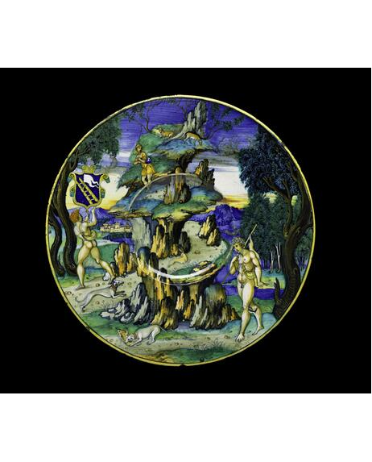

For the bibliog. abbreviations, see the online bibliography on my website https://timothywilson.co.uk
The inscriptions have not been thoroughly checked against the originals.
Thanks to Carmen Ravanelli Guidotti, Elisa Paola Sani, Michael Brody, Valentina Mazzotti, Claudio Paolinelli, Françoise Barbe, and Justin Raccanello for several pieces listed here.

Aeneid subjects by book

Book 1:
Quos ego subjects (including Juno and
Aeolus, and Venus and Cupids)
Aeneas with companions on arrival in Libya
Venus appearing to Aeneas and Achates
Aeneas hunting near Carthage
Aeneas at Carthage (the sunt lacrimae scene)
Dido receiving Aeneas in Carthage
Cupid in the guise of Ascanius conducted to
Dido by Achates
Dido and Aeneas feasting, with Ascanius

Book 2:
The capture of Sinon
Sinon before Priam
Laocoon
The Trojan horse
The Fall of Troy
Aeneas dreaming of the dead Hector
Pyrrhus killing Priam
Aeneas restrained by Venus from killing
Helen
Ascanius and the celestial flame
Aeneas, Anchises, and Ascanius escaping from Troy [with and without Creusa]
Aeneas encountering the ghost of Creusa

Book 3:
The arrival of Aeneas at Delos
Aeneas at the tomb of Polydorus

Book 4:
Dido bewailing the departure of Aeneas
The suicide of Dido

Book 5:
The arrival of Aeneas in Sicily
The boxing match of Entellus and Dares
The Trojan women setting fire to the Trojan ships
The death of Palinurus

Book 6:
Aeneas ferried to the Underworld by Charon
Aeneas meeting Anchises in the Elysian
Fields
Anchises showing Aeneas his descendants

Book 8:
Aeneas’s dream of the River Tiber
(identification of subject uncertain)
Aeneas at the house of Evander

Book 9:
Turnus and his troops
Turnus and his troops attack the Trojan
fortress
Aeneas’s ships burnt by Turnus transformed
into tree-nymphs

Book 11:
Metabus and Camilla
Mourners over the dead Camilla
(identification of subject uncertain)

Book 12:
Amata, Lavinia, Latinus, and Turnus
(identification of subject uncertain)

 | The arrival of Aeneas at Delos  Pesaro, 1498  Cité de la céramique, Sèvres, MNC8398  Bibliog: Ecouen 2011, no. 66  Although the story is in the Aeneid (Book 3, 73-120) the source of this plate is Ovid’s version in the Metamorphoses book 13, 623-704, and specifically the woodcut in the 1497 Ovidio Methamorphoseos vulgare  Some other Trojan War subjects on maiolica, such as the common Paris shooting Achilles, are in fact from the illustrated Metamorphoses. | 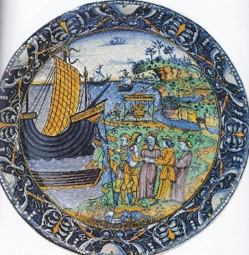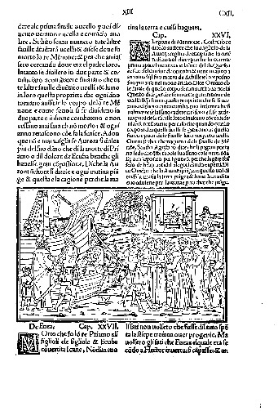
 | Amata, Lavinius, Lavinia, and Turnus  Probably Faenza, c1515-25  Uninscribed.  J. Paul Getty Museum, Malibu  Bibliog: Hess 2002, no. 23  The subject provisionally (but plausibly) identified as a scene from Aeneid Book 12, 54-80, in which Lavinia’s mother Amata pleads with Turnus, before King Latinus, not to go to war. A very uncommon subject in Renaissance art. | 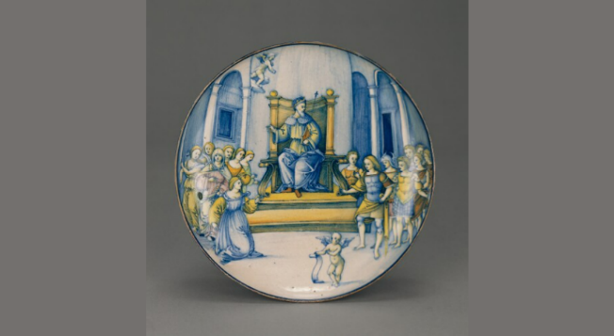
 | Dido and Aeneas and the suicide of Dido  Signed FR, possibly by Francesco Xanto Avelli in Urbino or elsewhere, c1522-5  National Gallery of Victoria, Melbourne. The figures on the right are after the engraving by G.A. da Brescia after parts of the Quos ego (see below).  The inscription on the front AENEAM.RECIPIT.PULCRA. CARTAGINE. DIDO. (virtually but not quite a hexameter line?) is from the engraving.  Bibliog: Wilson 2015, pp. 88-91. | 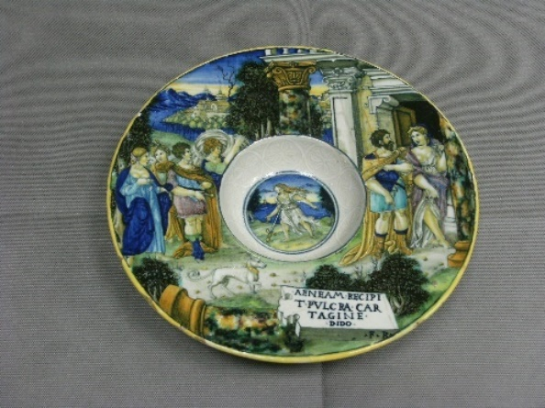
 | Dido receiving Aeneas in Carthage  Probably Castel Durante, c1520  MMA, New York, Lehman Collection, 1975.1.1006.  After the Giovanni Antonio da Brescia engraving after the Quos ego.  Bibliog: Rasmussen 1989, no.65. | 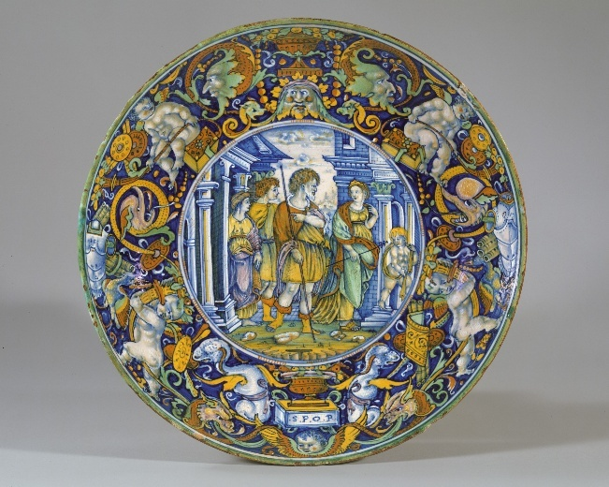
 | The suicide of Dido  Gubbio, workshop of Maestro Girgio, 1522.  After the engraving by Marcantonio after Raphael.  MMA, New York, 27.97.31  Bibliog: Wilson 2016, no. 73.  The iconography of Dido resembles that of Lucretia, but she is distinguished by the presence of the flames. | 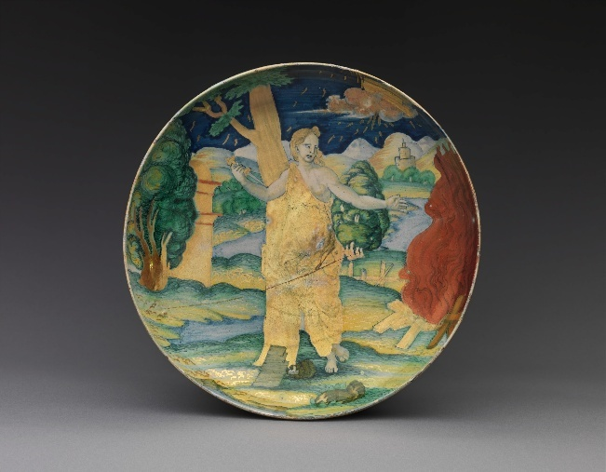
 | The suicide of Dido  Engraving by Marcantonio Raimondi after Raphael. | 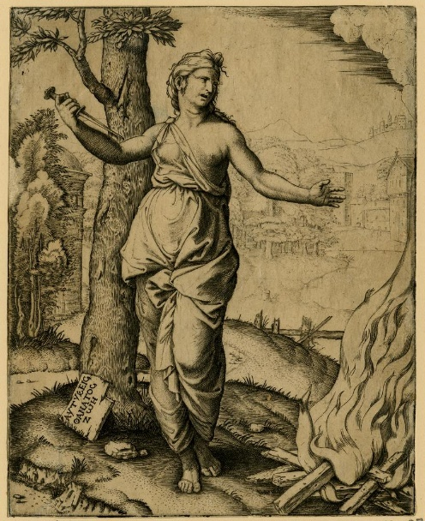
 | The suicide of Dido  Faenza, 1526, workshop of Piero and Paolo Bergantini, perhaps by the Painter of the Bergantini bowl. Armorial.  Inscribed with an unexplained inscription: Novos ex (?) ceteris viri ut vults ad virom vado 1526.  Galleria Estense, Modena  Bibliog: Sassuolo 2000, pp. 112-3. | 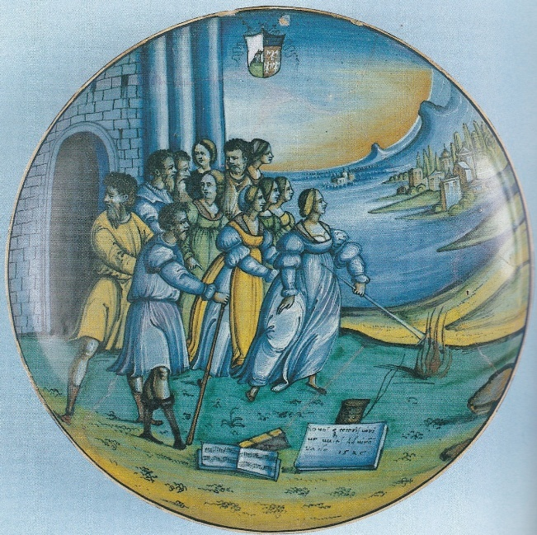
 | Dido and Aeneas feasting, with Ascanius  Initialled FR, perhaps Urbino, c1525, perhaps by Francesco Xanto Avelli  After the G.A. da Brescia engraving after the Quos ego,  V&A, C.2117-1910  Bibliog: Mallet 2007 (Xanto), no. 14 | 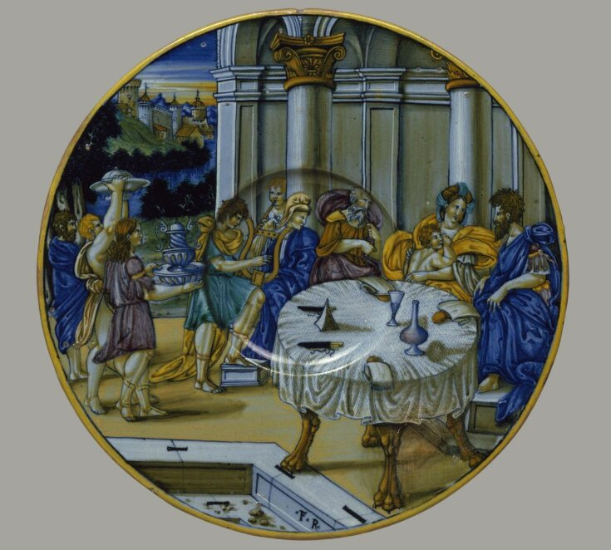
 | G. A da Brescia, engraving, two scenes from the Quos ego, reversed. | 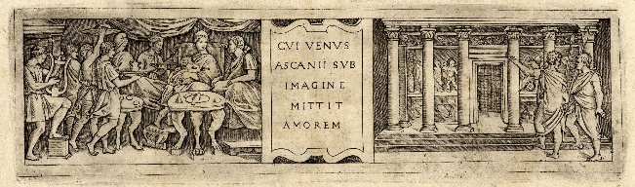
 | Dido and Aeneas feasting, with Ascanius  Castel Durante, 1526, by the “In Castel Durante” painter.  British Museum, BEP1855,1201.97  After the G.A. da Brescia engraving after the Quos ego,  Bibliog: Thornton & Wilson 2009, no. 152 | 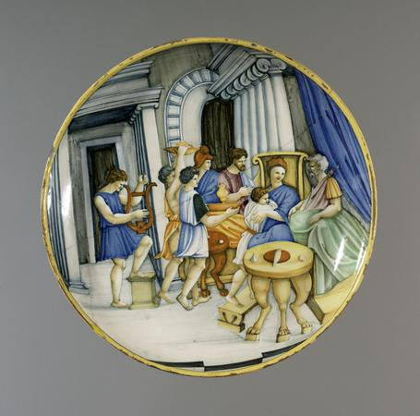
 | Dido and Aeneas feasting, with Ascanius  Urbino, probably by the “Decollation Painter”, c1530  Inscribed with a misidentification of the subject: Quando Anea vene in Italia.  Museo Civico Medievale, Bologna  Loosely after the engraving by G.A. da Brescia from the Quos ego.  Bibliog: Ravanelli Guidotti 1985, no. 104; and for the attribution and naming of the painter: Mallet 2010, p. 18; Wilson 2018, nos 87, 174, 175; Sani 2022. | 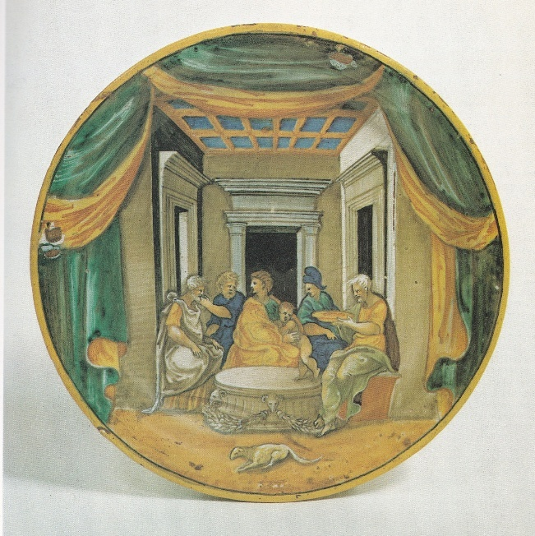
 | Dido and Aeneas feasting, with Ascanius  Probably Urbino, dated 1536; attributed by Christie’s to Xanto, but this is unconfirmed  Inscribed: 1536, Cui Venus Ascanii su imagine mittit amorem  Christie’s, London, 14 July 1980, lot 211.  After the engraving by G.A. da Brescia after the Quos ego. | 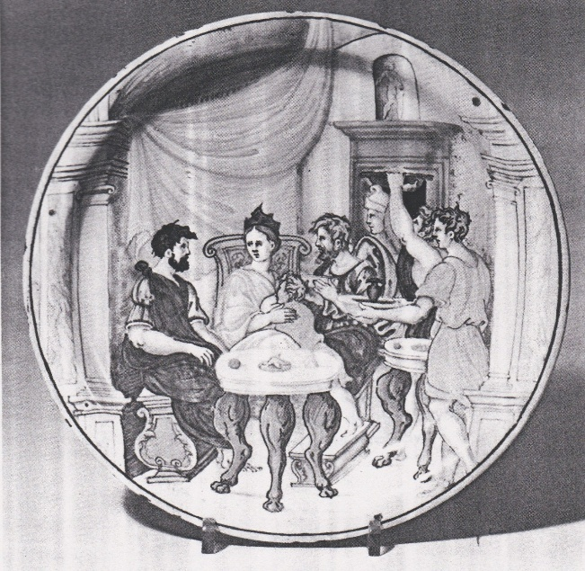
 | The boxing match of Entellus and Dares  Probably Castel Durante, c1525-30, by “the In Castel Durante painter”  Fondazione Cassa di Risparmio di Perugia.  Another version was in the Berney sale, 1946, lot 45; another, lustred and dated 1532, was in the Bak sale, 1965, lot 62.  Bibliog: Wilson and Sani 2006-7, I, no. 32. | 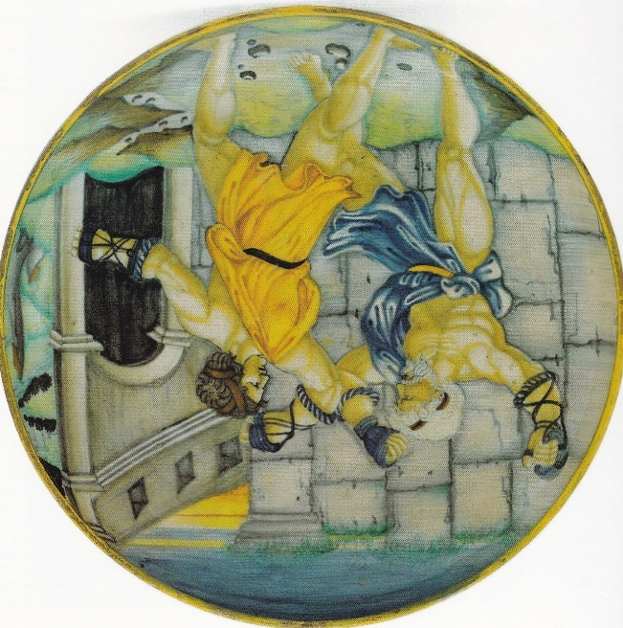
 | Entellus and Dares  Engraving by Marco da Ravenna, probably after Raphael or Giulio Romano | 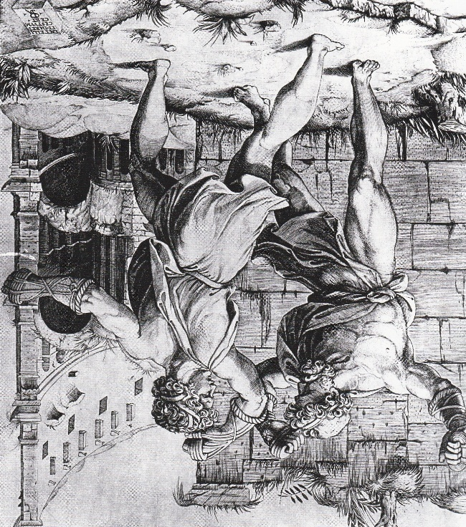
 | Dido receiving Aeneas in Carthage  Urbino, c1530, by the Milan Marsyas Painter.  Wyvern collection  Figures based on the engraving by G.A. da Brescia after the Quos ego.  Bibliog: Kaucher 2024, no. 49 | 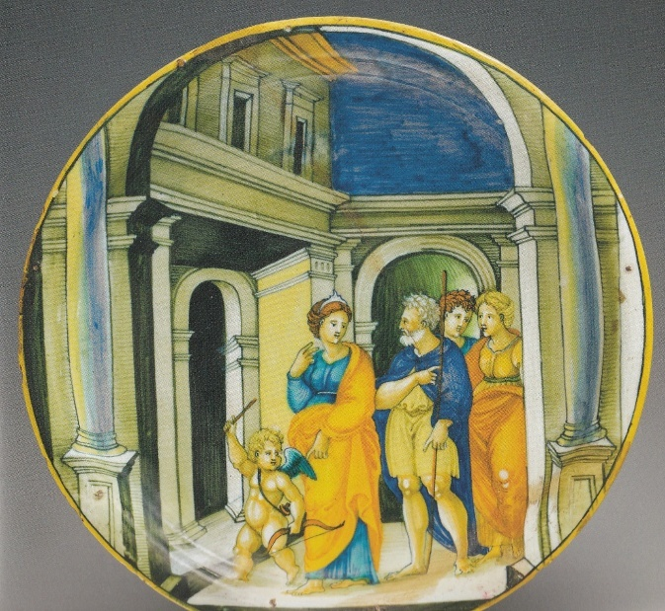
 | Cover of a birth bowl, Venus appearing to Aeneas and Achates  Urbino, by the Milan Marsyas Painter, c1530  Museo Nazionale, Ravenna  Bibliog: Kaucher 2024, no. 86  Figures after the G.A. da Brescia engraving after the Quos ego, | 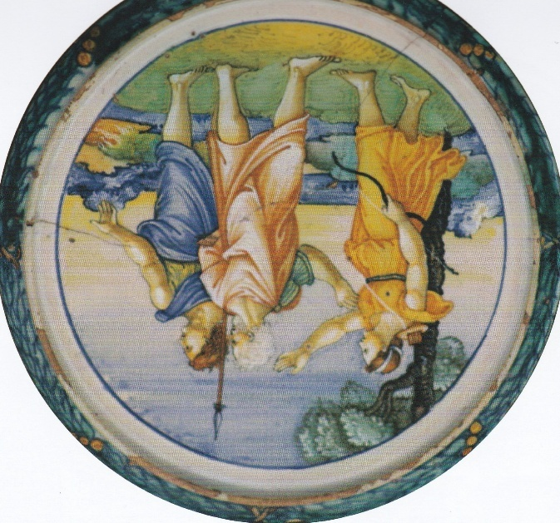
 | G. A da Brescia, engraving, four scenes from the Quos ego, reversed. | 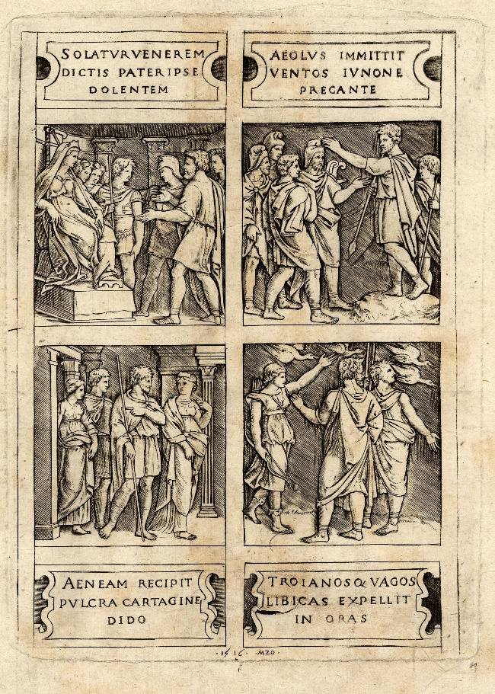
 | Scene identified as Tiber wooing Manto (being part of the foundation myth of Mantua).  Urbino, from the service made by Nicola da Urbino for Eleonora Duchess of Urbino to give to her mother Isabella d’Este, Marchioness of Mantua, 1524.  Kunstgewerbemuseum, Berlin  Bibliog: Hausmann 1972, no. 171 (ex-Pringsheim).  Paul Taylor says the Warburg fototeca does not have any images of this scene but thinks the identification plausible, obviously with Isabella in mind. | 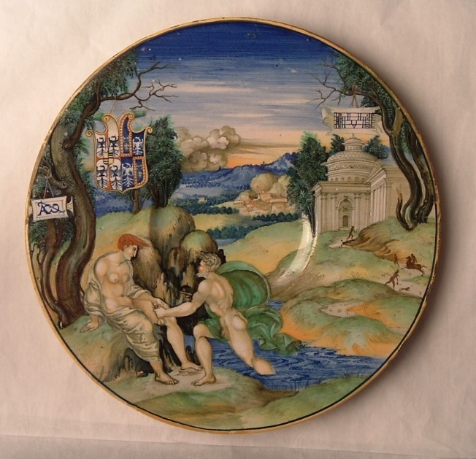
 | Aeneas, Anchises, and Ascanius escaping from Troy  Urbino, from the service made by Nicola da Urbino for Eleonora Duchess of Urbino to give to her mother Isabella d’Este, Marchioness of Mantua, 1524.  Probably based directly or indirectly (it is reversed from the woodcut) on the Ugo da Carpi woodcut of 1518 (below). The Caraglio print lacks the household gods and is anyway probably post-1524.  Currently with Altomani; ex-Morosini, Mannheim, Morgan, Hearst, Caruso, and De Tomaso collections. | 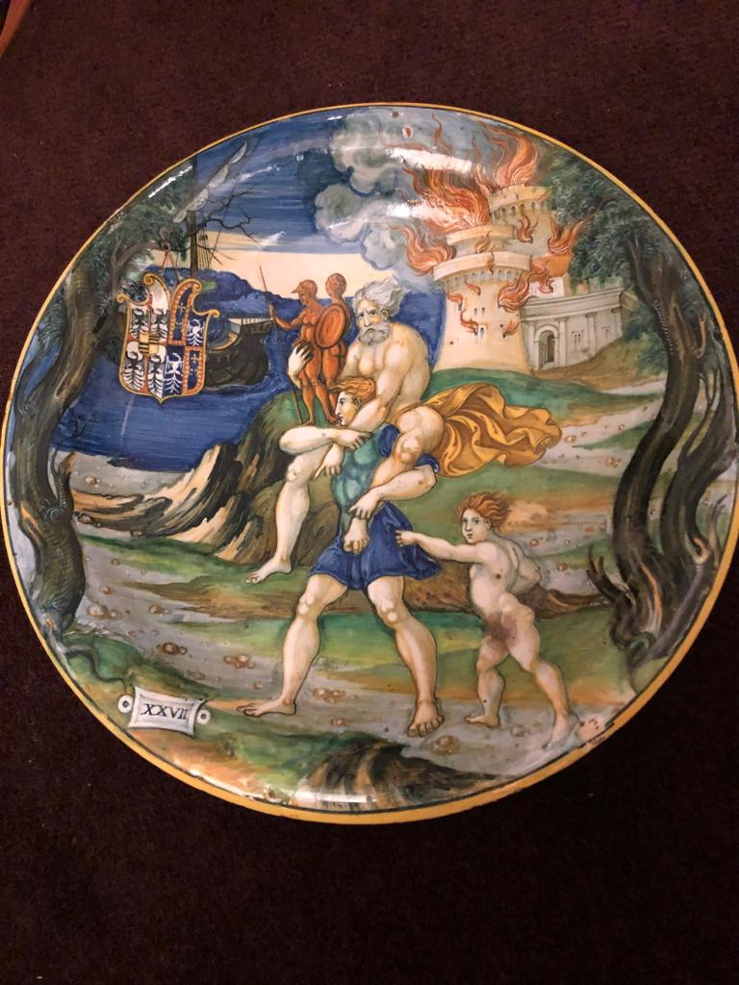
 | Aeneas and Anchises. Woodcut by Ugo da Carpi, dated 1518, in which for the first time the figures from Raphael’s Fire in the Borgo from the Vatican Stanze (1514) are adapted to represent Aeneas and Anchises. | 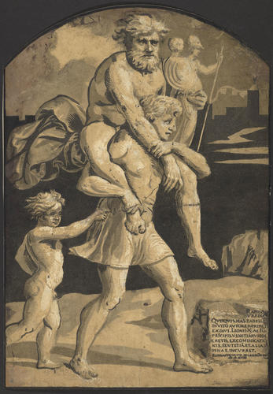
 | Aeneas and Dido feasting, with Ascanius  Urbino, from the service made by Nicola da Urbino for Eleonora Duchess of Urbino to give to her mother Isabella d’Este, Marchioness of Mantua, 1524  Louvre, OA12206  Figures after the G.A. da Brescia engraving after the Quos ego,  Bibl: Ecouen 2011, no. 68. | 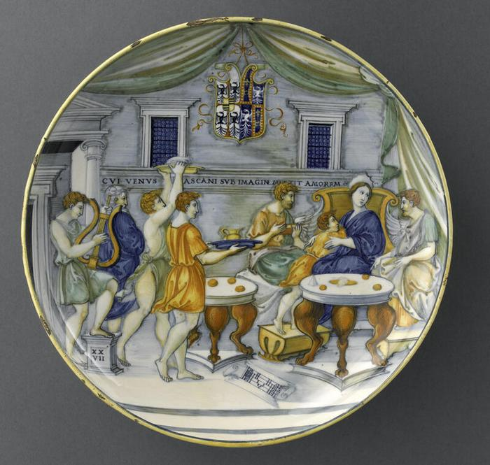
 | Aeneas at the house of Evander, with Venus and Vulcan  Urbino, by Nicola da Urbino, c1530  Milan, Castello Sforzesco  Inscribed: Chomo aenea Ciercho tutti liteti de Evandro.  Based on a woodcut in the Virgilio volgare of 1528, the wording of which is echoed in Nicola’s inscription.  Bibliog: Wilson in Ausenda 2000, no. 195; Ecouen 2011, no. 69. | 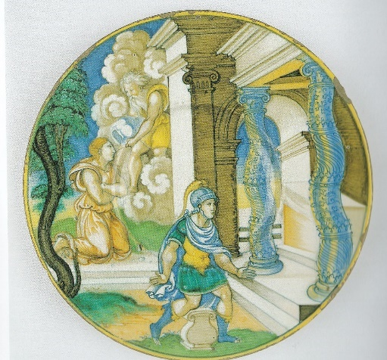
 | Woodcut opening Book 8 of Virgilio volgare, Venice (Zoppino), 1528 | 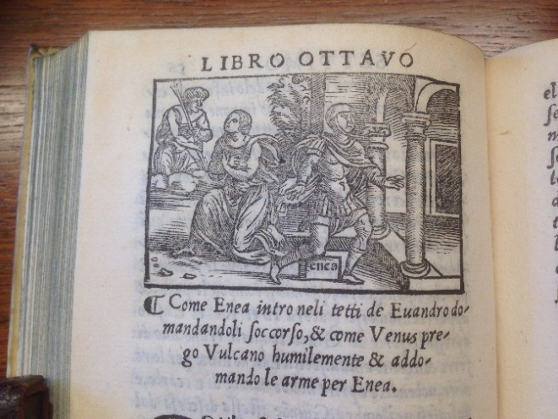
 | Turnus and his troops  Urbino, by Nicola da Urbino, c1530-35  Inscribed in Nicola’s handwriting:  Come apparve Iris aturno ardito al quale Stava nela sacrata valle e disse gli come .E.neas’apparichiava a la battaglia  Louvre, OA11759.  Bibliog: Mallet 2007 (Nicola), no. 98.  Possibly part of a service with the Milan plate above? | 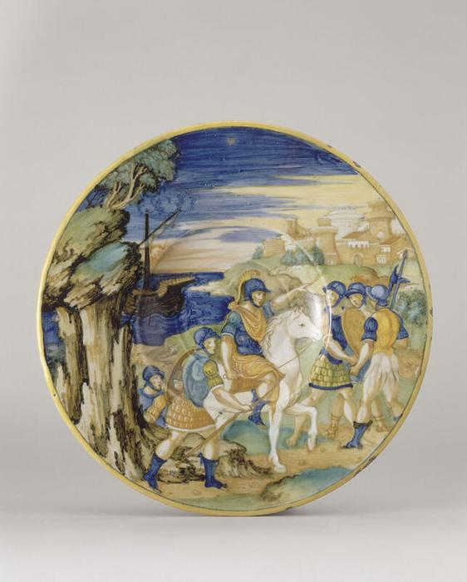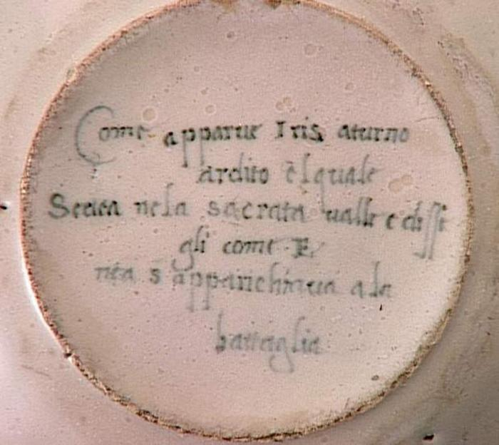
 | Woodcut and text opening Book 9 of Virgilio volgare, 1528.  The text of both the chapter summary in the book and Nicola’s inscription taken from it mentions Iris, but she does not appear in the woodcut or on the plate. | 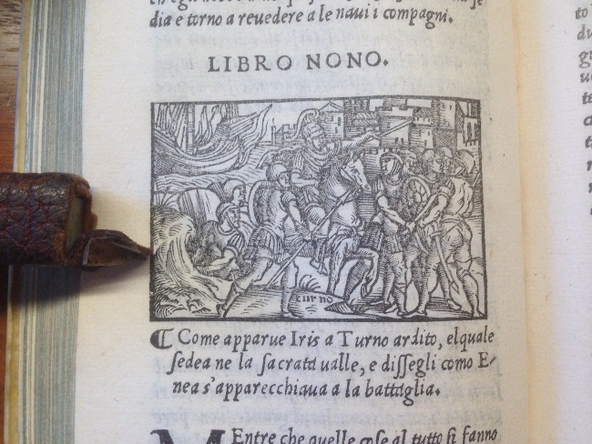
 | Turnus and his troops attack the Trojan fortress  Urbino, by Francesco Xanto Avelli, 1541  Inscribed: .1541.Turno d’intorno alla novella Troia .X.  Musée des Arts décoratifs, Lyon.  Bibliog: Fiocco and Gherardi 2001, no. 158.  Partly based on the Virgilio volgare woodcut above, but the castellated encampment echoes an engraving of the Capture of New Carthage after Giulio Romano (of which there are versions by Georg Pencz and Marco da Ravenna) | 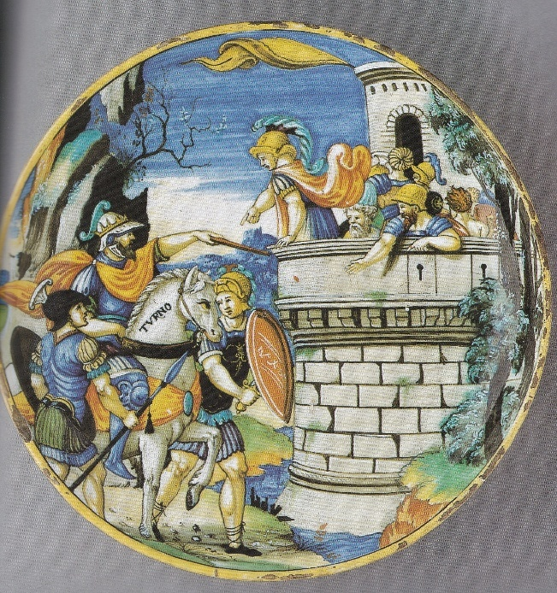
 | Venus, Cupids and doves, central vignette of a young man  Gubbio, workshop of Maestro Giorgio Andreoli, 1525. Lustred.  MMA, New York, 41.100.280  Bibliog: Wilson 2016, no. 78B  The figures on the border, but not the one in the well, are from the engraving by G.A. da Brescia after the upper register of the Quos ego. | 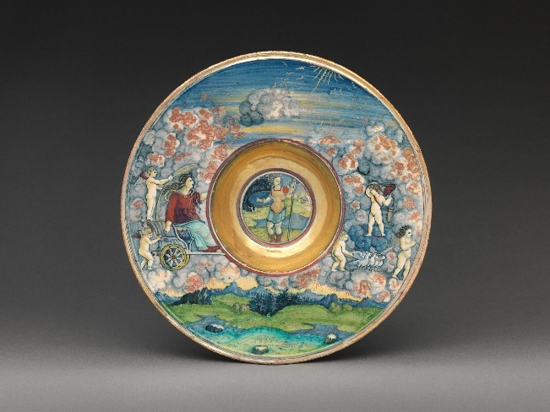
 | Juno and Aeolus, central vignette of an old man  Gubbio, workshop of Maestro Giorgio Andreoli, 1525. Lustred.  MMA, New York, 41.100.279  Bibliog: Wilson 2016, no. 78A  The figures on the border, but not the one in the well, are from the engraving by G.A. da Brescia after the upper register of the Quos ego. | 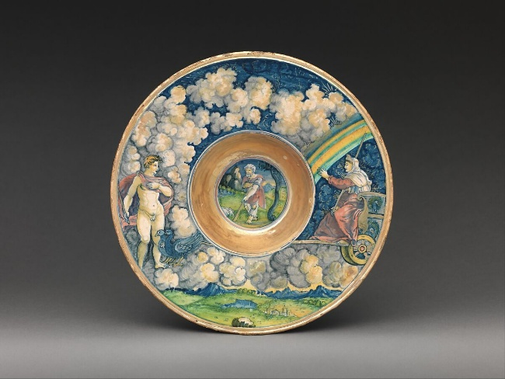
 | G. A da Brescia, engraving, top row of scenes from the Quos ego, reversed. | 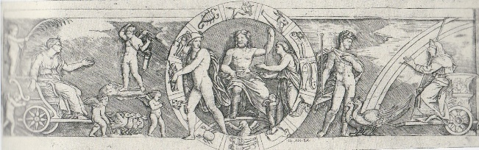
 | Dido and Aeneas feasting, with Ascanius  Perhaps Castel Durante, c1530  Inscribed on the front: CUI VENUS ASCANII SUB IMAGINE MITTIT AMOREM  Petit Palais, Paris  The figures and inscription are from the vignette in the Quos ego (the G.A da Brescia copy is in the other direction).  Set in a spectacular architectural surround.  Bibliog: Ecouen 2011, no. 63. | 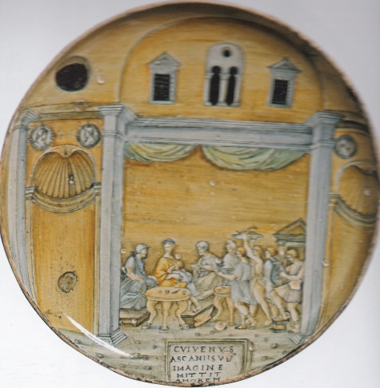
 | Aeneas with companions on arrival in Libya  Urbino, perhaps by a close associate of Nicola da Urbino, c1530; the inscription apparently in Nicola’s handwriting.  Inscribed: AeVlus inmittit Ventos iunone precante  After a vignette in the Quos ego, but with an inscription erroneously taken from the caption in the engraving referring to the vignette above it (an error repeated in the G.A. da Brescia engraving but that is in the other direction).  Fitzwilliam Museum, Cambridge, C.85-1961  Bibliog: Poole 1995, no. 379, as probably by Nicola, but not included in Mallet’s 2007 list. Fitz website now says possibly by Nicola, possibly by the Milan Marsyas Painter; but not included in Kaucher. | 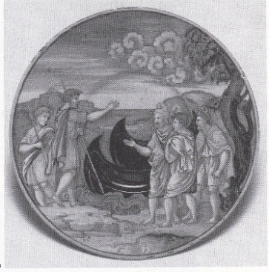  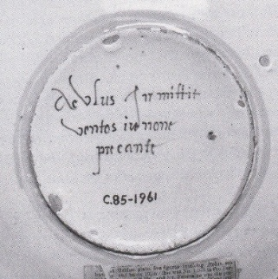
 | Aeneas with companions on arrival in Libya  Gubbio, marked as made in the workshop of Maestro Giorgio, dated 1529. Lustred.  After the engraving, reversed from the Quos ego, by G. A. da Brescia.  Kestner Museum, Hanover  Bibliog: Brunner 2003, p. 32. | 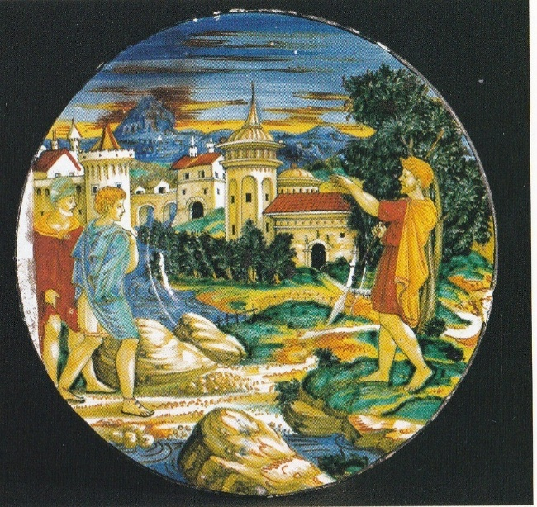
 | Aeneas with companions on arrival in Libya  Urbino, the painting perhaps by a close associate of Nicola da Urbino, c1530; the inscription apparently in Nicola’s handwriting.  Inscribed: eVlus inmitit ventos.  Kunstgwerbemuseum, Schloss Pillnitz, Dresden.  The figures after the same Quos ego vignette, with the same inscription error as the Fitz plate above, and the painting probably by the same associate of Nicola.  Bibliog: Richter 2006, no. 89 (as workshop of Guido Durantino). | 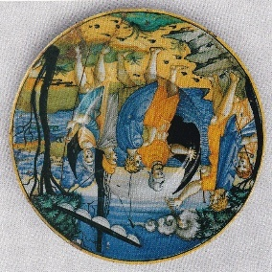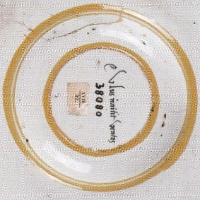
 | Aeneas with companions on arrival in Libya  Urbino, 1536.  Inscribed: Aeulus immitit ventos ionone precante.  Herzog Anton Ulrich Museum, Braunschweig  After the same Quos ego vignette, with the same inscription error as the plates above, and with the same spelling of “Aeulus” Bibliog: Lessmann 1979, no. 293. | 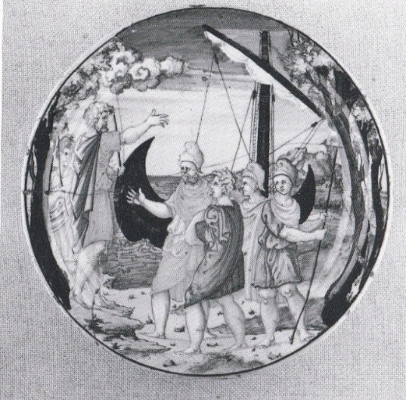
 | Aeneas with companions on arrival in Libya  Urbino, by Francesco Xanto Avelli, c1530.  Inscribed: Gli feri venti ad Eulo ubidienti fabula with the y/Φ flourish  After a vignette in the Quos ego, but with an inscription erroneously taken from the caption in the engraving referring to the vignette above, repeating the error in the Fitz and Dresden plates above.  Ex-Berney collection; Sotheby’s, London, 11 March 1980, lot 17.  Bibliog: Sani 2007, no. 61.  So three distinct Urbino painters make the same iconographical error. Possibly copying a prototype by Nicola? | 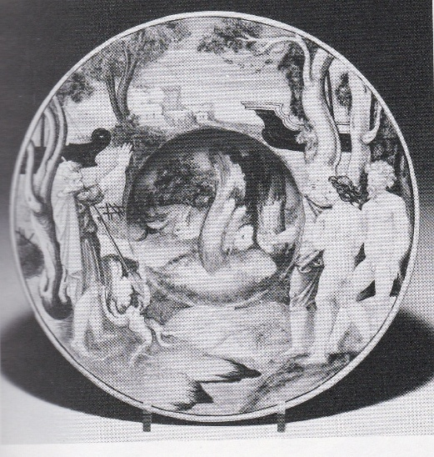
 | Aeneas with companions on arrival in Libya  Gubbio, workshop of Maestro Giorgio, c1530-35. Lustred.  After the engraving, reversed from the Quos ego, by G. A. da Brescia.  No inscription. A lustred fleur-de-lis on the back.  Sam Fogg collection, London (ex Lyon and Turnbull, Edinburgh, 6 October 2021, lot 65) | 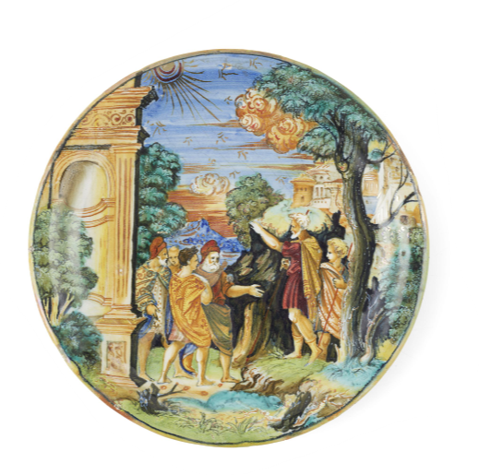
 | Aeneas with companions on arrival in Libya  Urbino, c1530, attributed to a painter close the Milan Marsyas painter  After the engraving, reversed from the Quos ego, by G. A. da Brescia.  No inscription.  With Raccanello/Leprince, 2025 | 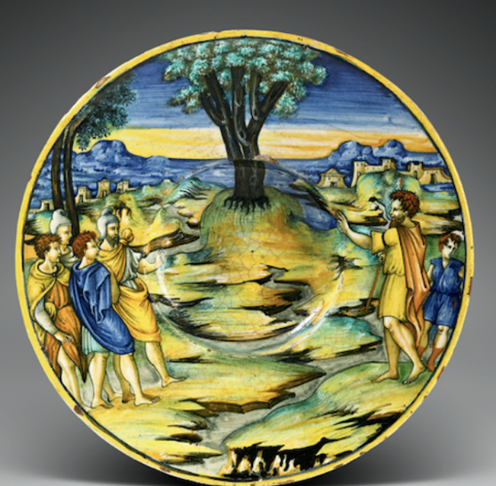
 | Metabus and Camilla  Urbino, By Francesco Xanto Avelli, probably 1530, from the Three Crescents service.  Private collection.  Kaucher 2024, Appendix, no. II.  For later versions of this subject by Xanto, see below; also for one dated 1543 and initialled P. | 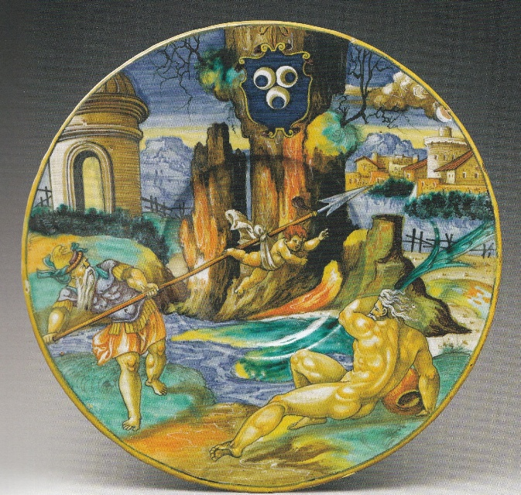
 | Venus appearing to Aeneas and Achates  Urbino, by Francesco Xanto Avelli, dated 1530, from the Three Crescents service.  Inscribed: Troianos q vagos libicas expellit i[n] oras.  The figures and inscription are from the engraving by G.A. da Brescia after the Quos ego.  MMA, New York, Lehman Collection, 1975.1.1136  Bibliog: Rasmussen 1989, no. 76. | 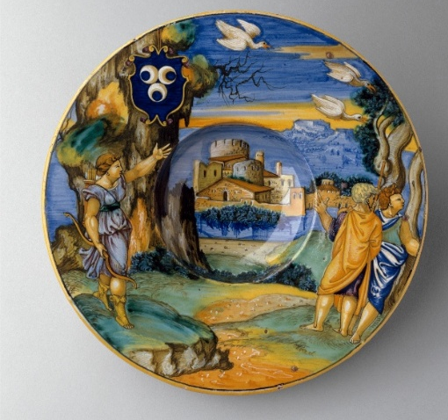
 | Aeneas, Anchises, and Ascanius escaping from Troy.  Urbino, by Francesco Xanto Avelli, c1528-30, from a set with unidentified arms.  Inscribed: .1531. Quest’ è colui ch’a Troia il padre Anchise Trasse d’il fuoco, et dopo lo[n]go errore Sotto la ripa Antantra a posar mise historia followed by the y/Φ flourish..  Kunstgewerbemuseum, Cologne.  The figures and inscription are from the  Engraving by G.G. Caraglio after Raphael’s design for the Fire in the Borgo (below).  Bibliog: Klesse 1966, no. 309 | 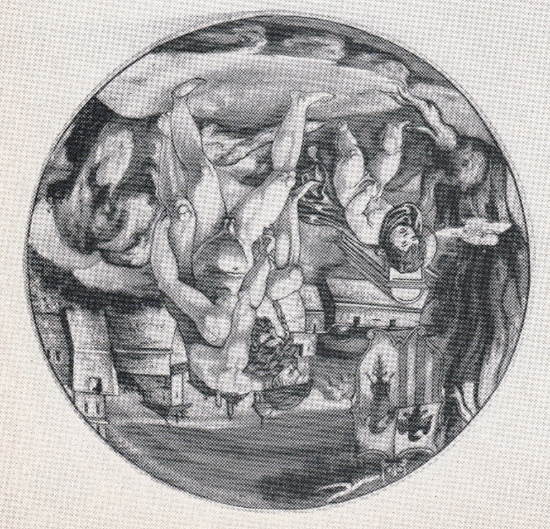
 | Aeneas, Anchises, and Ascanius escaping from Troy.  Urbino, by Francesco Xanto Avelli, 1531 from the “Hercules” armorial set.  Inscribed: .1531. Quest’ è colui che pia[n[se sotto Antandro. historia.  fra[n]cesco: Xanto, Avelli da Rovigo .i[n] Urbino pi[n]se.  The inscription is slightly adapted from  Petrarch’s Trionfo d’amore, I, 106-7:  L’altro è colui che pianse sotto Antandro  La morte di Creusa  After the engraving by G.G. Caraglio after Raphael’s design for the Fire in the Borgo.  British Museum, BEP1855,1201.45  Bibliog: Thornton & Wilson 2009, no. 160 | 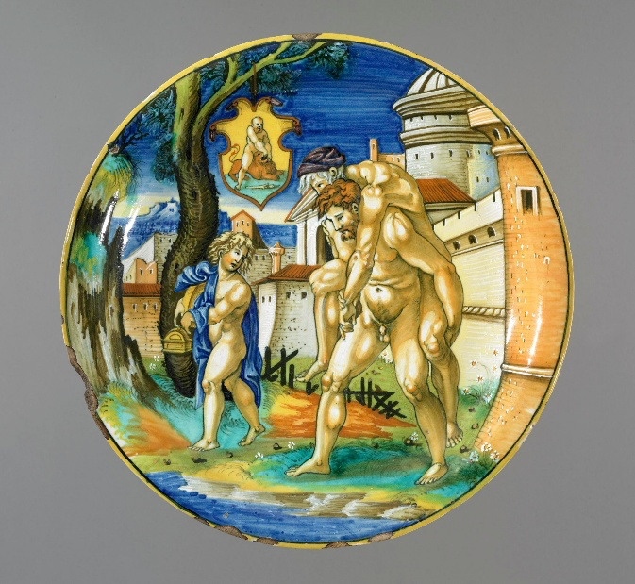
 | Aeneas, Anchises, and Ascanius escaping from Troy.  Engraving by G.G. Caraglio after Raphael’s design for the Fire in the Borgo. The British Museum website gives a broad dating for this print, c1520-39, but its use on the MICF fragment (below) proves that it was made around 1525, though Caraglio is first recorded in the circle of Marcantonio in 1526. The inscription distantly echoes Petrarch. | 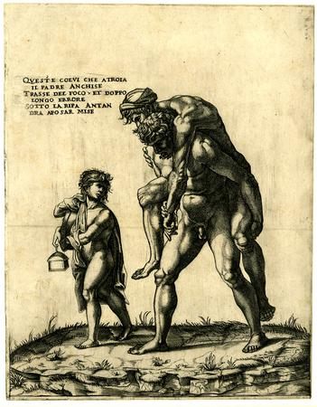
 | Aeneas, Anchises, and Ascanius escaping from Troy.  Urbino, by Francesco Xanto Avelli, 1532; lustred in Urbino or Gubbio.  After the engraving by G.G. Caraglio after Raphael’s Fire in the Borgo.  Inscribed: .1532. Enea col padre Anchise e’l figlio Ascanio. Nel .II. Li: d[e] l’Eneida d[i] V.M.  fra[ncesco]: Xanto. A da Rovigo .i[n] Urbino.  With Altomani 2025; ex De Tomaso coll; ex Caruso sale, Soth, London, 20 March 1973, lot 37. | 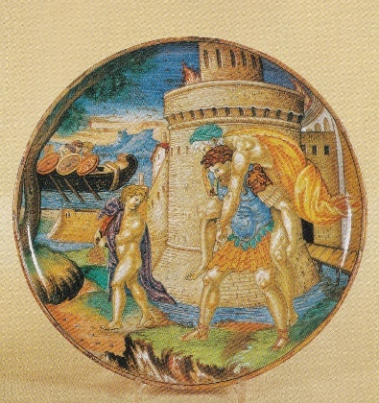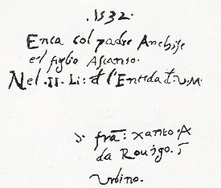
 | The subject of Aeneas and Anchises escaping Troy was often represented by Xanto, always (I think) using the figures from the Caraglio engraving. They date between c1530 and 1542. Among the earliest, c1528-30, is one in Braunschweig (Sani 2007, no. 71; Lessmann 1979, no. 141) inscribed trass’ il padre d’il fuoco il pio enea. historia. Others are Sani 2007, nos 81 (c1530), 399 (1542); also the panel in Braunschweig, below. An elaborate version by a follower or associate of Xanto is in the MMA, New York, 27.97.27. The composition was still current in Venice in the 1560s and perhaps later (Braunschweig, below).
 | Aeneas and Anchises escaping from Troy.  Probably Castel Durante, by the In Castel Durante painter, c1525-30.  Uninscribed.  Copied in reverse from the engraving by Caraglio (above)  Museo Internazionale delle Ceramiche, Faenza; ex Berney.  Bibliog: Ravanelli Guidotti 1983 (“Iconografia”), no. 136  Unusual in being reversed from the engraving. | 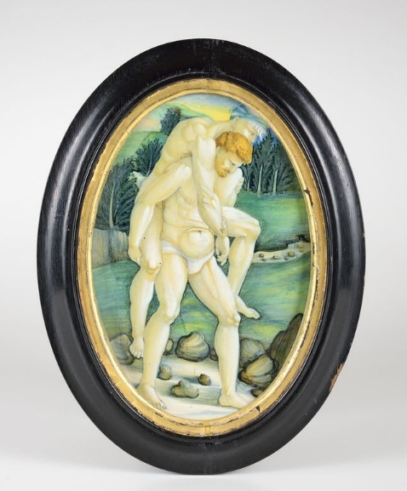
 | Aeneas, Anchises, Creusa, and Ascanius escaping from Troy.  Probably Castel Durante, perhaps by the In Castel Durante painter, c1525-30 (but I need a better photograph)  Inscribed on the front (as transcribed by Fuchs): Conduce Enea for de la gran Troia AcoHon Patr.inCendioSa Hora  Museo d’arte medioevale e moderna, Arezzo  Bibliog: Fuchs 1993, no. 214.  No more than an echo of the Caraglio engraving? | 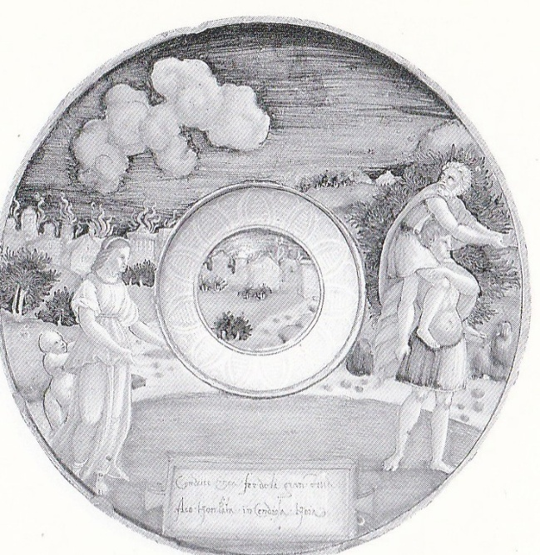
 | Bowl from a birth set, Aeneas, Anchises, Creusa, and Ascanius escaping from Troy.  Faenza, by Baldassare Manara, c1530-40  Inscribed: … QUEl.CHE. QUAL.SALAMANDRA.LA. VIA.PRESSE.IN.MEGIO.AL.FOCHO.COL.IULIO.ET ANCHISO…  MMA, New York, Lehman Collection, 1975.1.1043  Bibliog: Rasmussen 1989, no. 28.  Vague if any resemblance to the Caraglio engraving. | 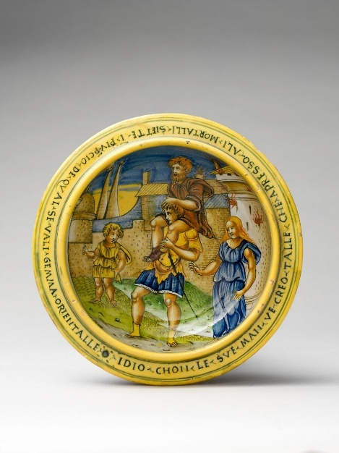
 | Aeneas hunting near Carthage  Urbino, by Francesco Xanto Avelli, 1532, the largest plate of the Pucci service. The scene is from Aeneid book 1, 180-97.  Inscribed in terza rima no doubt composed by Xanto (there was a terza rima translation of the Aeneid printed in 1532 (without narrative woodcuts; Kallendorf 10), but there is no link):  M.D.XXXII  In libia giunto Enea co[n] sette navi  Co[n] li compagni tiro dal bosco al Lito  Sette gra[n] cervi po[n]derosi & gravi  Nel .I. Libro del Eneida [ver]giliana  F. Xa[n]to A.R. i[n] Urbino;  Also signed in white on a tablet on the front.  Private collection (Pucci family?), ex-George Berney, Fountaine, Strauss; Christie’s 21 June 1976, lot 46.  Julia Triolo thinks this has a direct relationship to the Virgilio volgare, but this does not seem to me obvious.  Bibliog: Triolo 1988, no. 1  An unusual subject for the largest piece of this substantial service?  Another version of the subject, by the Eloquence painter, Venice, c1550-60, inscribed De cervi Enea cibo fece sue navi is in Braunschweig (Lessmann 1979, no. 564). | 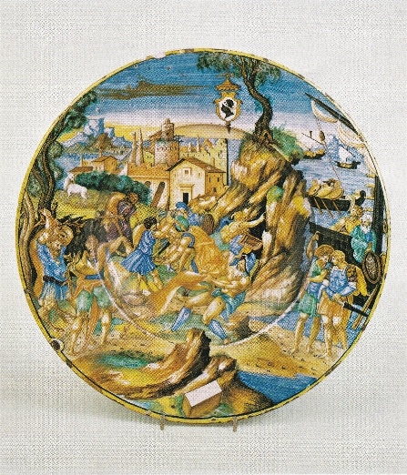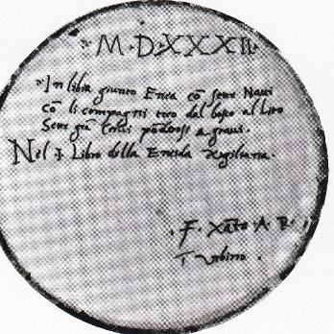
 | Aeneas at Carthage (the sunt lacrimae scene)  Urbino, by Francesco Xanto Avelli, 1532, from the Pucci service.  Inscribed: .1532. Le battaglie Troiane Enea co[n]templa. Nel I Libro de l’Eneida V f. Xanto A. da Rovigo, i[n] Urbino.  Knightshayes (National Trust), ex-Berney  The scene takes as its starting point the vignette in the Quos ego engraving, but is much varied.  Bibliog: Triolo 1988, no. 2. | 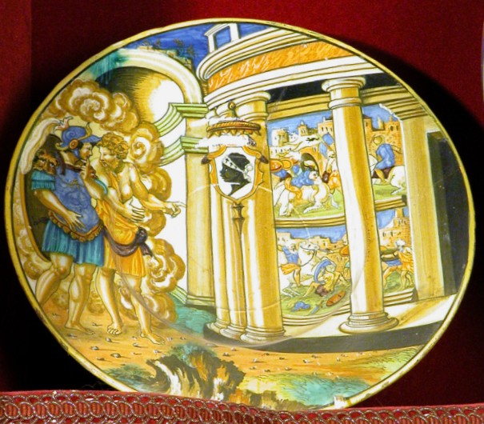
 | Aeneas, Anchises, Creusa, Ascanius, and the celestial flame  Urbino, by Francesco Xanto Avelli, 1532, from the Pucci service.  Inscribed: 1532. Sovra Ascanio larde una Celeste Fiamma. Nel.II. Libro d[e] l’Eneida. V. fra[n]: Xanto. A. da Rovigo i[n] Urbino  Private collection.  Triolo suggests that Xanto was aware, directly or indirectly, of the illustration in the fifth-century “Vatican Virgil”, known in the circle of Raphael in Rome about 1515 and later the property of Pietro Bembo; but this seems to me unsubstantiated.  Another version of the subject by Xanto from the Jacopo Pesaro service, 1535, in V&A (below). Another from the Trojan War series designed by Battista Franco for Duke Guidubaldo about 1547 in the Musei Civici, Pesaro (Clifford & Mallet 1976, no. 17; see below, towards the end).  Bibliog: Triolo 1988, no. 3; Wilson 2018, no. 105. | 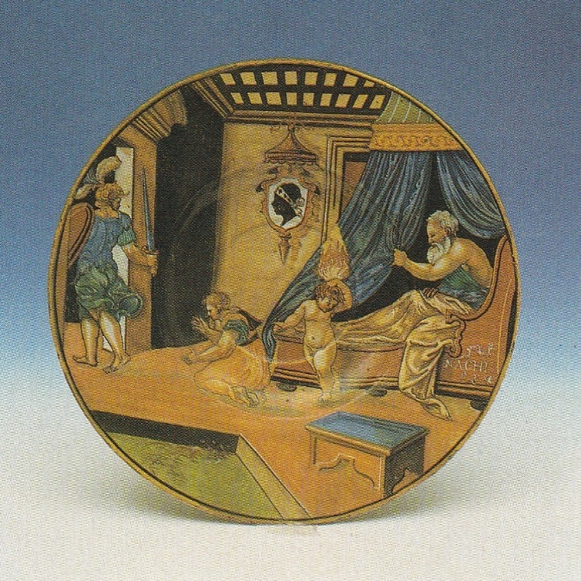  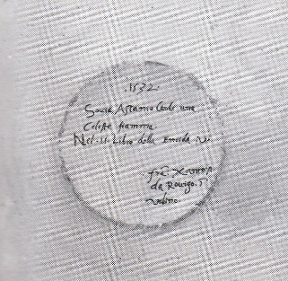
 | Aeneas at the tomb of Polydorus  Urbino, by Francesco Xanto Avelli, from the Pucci service, 1532. Lustred in Gubbio or possibly in Urbino.  Inscribed: .1532. Enea, d[i] Polidor giunto al sepulcro. Nel .III. libro d[i] l’Eneida. V. .fra[n]: Xanto .A. da Rovigo, i[n] Urbino.  The composition makes use of the woodcut in the Virgilio volgare of 1528  MMA, NY, Lehman Collection, 1975.1.1131.  Bibliog: Triolo 1988, no. 4; Rasmussen 1989, no. 80. | 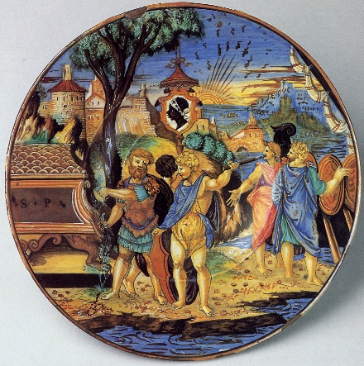
 | Woodcut opening Book 3 of the Aeneid from the Virgilio volgare of 1528. | 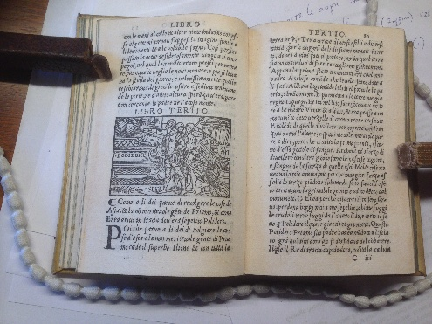
 | The Death of Palinurus  Urbino, 1532, by Francesco Xanto Avelli, from the Pucci service.  Inscribed: .1532. Palinuro nochier tra l’onde affoga. nel. V. Libro de l’Eneida. V.. fra[n]; Xanto .A. da Rovigo, i[n] Urbino  Los Angeles County Museum of Art, 50.9.28  Bibliog: Triolo 1988, no. 5 | 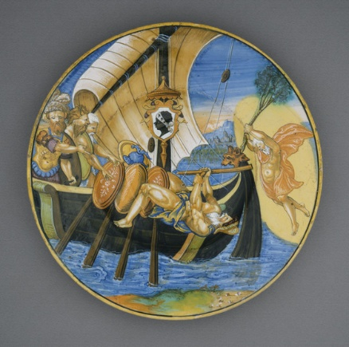
 | Similarly-composed versions of the Palinurus subject signed by Xanto are in the V&A (1535), the Taft Museum, Cincinnati (1535) and a lustred fragment excavated in the Palazzo della Cancelleria, Rome. Also one dated 1537, ex Alain Moatti collection (Ravanelli Guidotti 2007, p. 83, figs. 8a-b); sold Sotheby’s, NY, 7 February 2025, lot 654.
 | Metabus and Camilla  Urbino, by Francesco Xanto Avelli, 1532, from the Pucci service.  Inscribed:1532/ Al fiume d’Amassen’ Camilla, e’l padre. nel .XI. lib: d[e] l’Eneida Virg: Fra[n]: Xanto A: da Rovigo i[n] Urbino.  Location unknown, ex-Kolkhorst collection  Bibliog: Triolo 1988, no. 6.  For the Camilla subject, see above and below. | 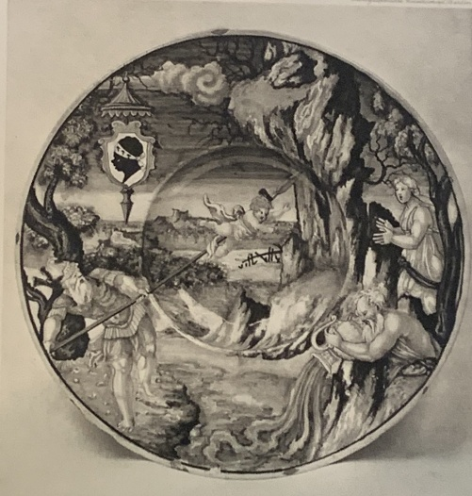
 | Panel, Sinon before Priam  Urbino, by Francesco Xanto Avelli,  c1530-35  British Museum, BEP1906,1210.1  This and the following three panels by Xanto, and also probably the following four by Nicola, look likely to be from a single set, which may be the earliest such near-systematic treatment of ancient “history” on maiolica; in 1536 Xanto painted a long and more detailed series of subjects from Persian history after Justin’s Epitome of Trogus Pompeius.  Bibliog: Thornton & Wilson 2009, no. 159. | 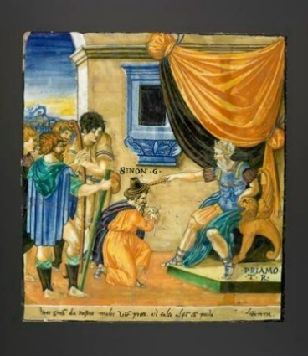
 | Panel, Aeneas dreaming of the dead Hector  Urbino, by Francesco Xanto Avelli,  c1530-35  Hector has a scroll: Fuggi O pietoso Enea di Dea figliuolo  Private collection  Bibliog: Wilson 2018, no. 108 | 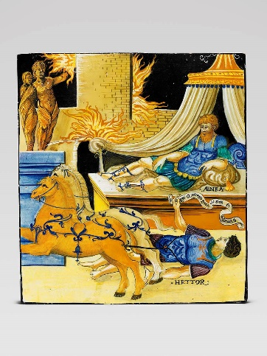
 | Panel, The battle between Achilles and Hector.  Urbino, by Francesco Xanto Avelli, c1530-35.  Hermitage  Inscribed: HECTOR, ACHILLE, and PA[N]TASILEA; and at the bottom Passa[n]do Hechtorre il bel fiume di XA[N]TO Fu dal superbo Achill’ per forza ucciso &.. followed by the y/Φ flourish.  Bibliog: Ivanova 2019, no. 13.  An Iliad, not Aeneid, subject. | 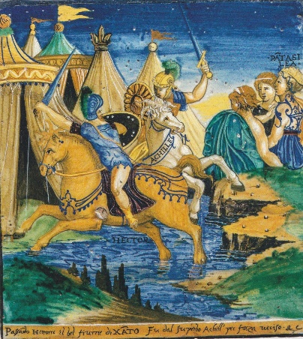
Panel, Aeneas, Anchises, and Ascanius escaping from Troy, with the death of Creusa  Urbino, by Francesco Xanto Avelli,  c1530-35  Herzog Anton Ulrich Museum, Braunschweig.  Inscribed: Questo è colui che pianse sotto / Antandro La morte di Creusa. e followed by the y/Ф flourish  The panel is the only version of the subject by Xanto to include Creusa and to give the Petrarch quote in full. |  | 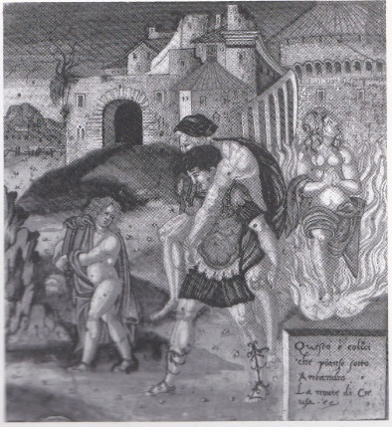
 | Four panels with scenes leading up to an episode from the Trojan War, Herzog Anton Ulrich Museum, Braunschweig. Lessmann 1979, nos 134-7 as by a close associate of Nicola da Urbino, c1525-30. Not specifically Virgilian (except for the last) but since they look likely to be part of a single set with the four Xanto panels above, they are included here:  1. The Judgement of Paris  2. The Abduction of Helen  3 The Oath of Agamemnon and Menelaus  4 The Trojan horse  Bibliog: Lessmann 1991.  The representation of the Trojan horse has similarities to the woodcut opening Book 2 in the Virgilio volgare:  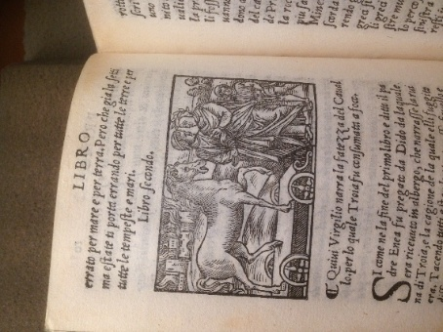 | 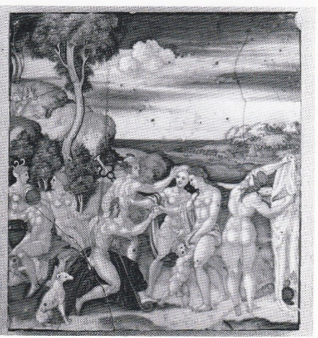  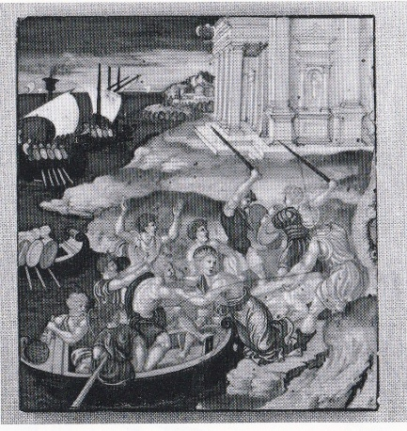  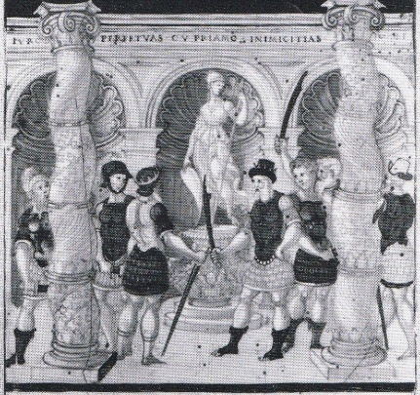  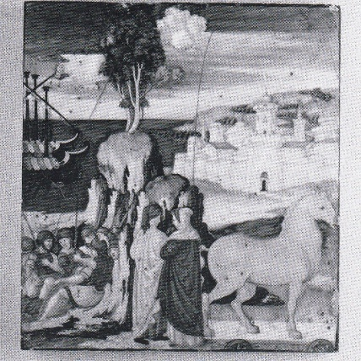
 | Metabus and Camilla.  Urbino, by Francesco Xanto Avelli, 1532.  Inscribed: .1532. Methabo oltr’Amasse’ lanciò Camilla. Nel.XI. Lib’ d[e]l Eneida .v. frâ: Xanto.A. da Rovigo, i[n[ urbino  Location unknown  Bibliog: Rackham 1959, no. 420; Pandolfini, Florence, 9 November 2016, lot 34 | 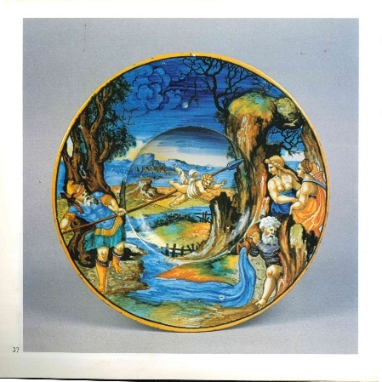
 | Metabus and Camilla.  Urbino, by Francesco Xanto Avelli, 1533.  Inscribed: 1533 il fortunato sca[m]po de Camilla nel XI libro del Eneida .v.  fra: Xa[n]to. A. da Rovigo. i[n] Urbino.  Louvre, N 75 (MRR 132)  Bibliog: Giacomotti 1974, no. 850: Sani 2024B, p. 96, fig. 6. | 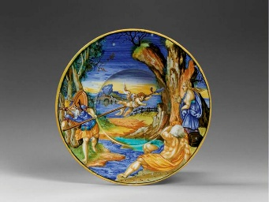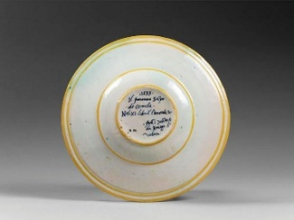
 | Metabus and Camilla  Inscribed: 1534/Metabo oltre Amasse[n] lancio Camilla Nel .XI libro de L’Eneida.x. Fra.Xa.A/Rovigiese i[n] Urbino  Urbino, by Francesco Xanto Avelli, 1534; lustred in Urbino or Gubbio  Gardiner Museum, Toronto, G83.1.363 | 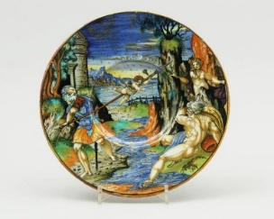  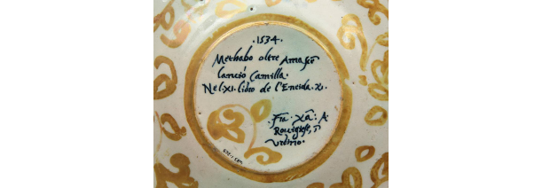
The Camilla subject from Aeneid book 11, 532-566 was one of Xanto’s favourites, the composition being assembled by him around 1530 from various prints (the Three Crescents service plate above) and re-used with variations until 1542. Other examples include Wilson 2025, no. 14 (c1530), Sani 2007, nos 236, 237 (1534), 354 (1538), 369 (1539), 396 (1541), 417 (1542). See Sani 2024B, p. 96. Four (the example above from the Pucci service, 1532, the other example of 1532 above, and the two of 1533 and 1534 illustrated immediately above give the reference to Book 11 of the Aeneid. There is no relationship to the woodcuts in the Virgilio volgare of 1528.
An unrelated version of the subject by Francesco Durantino or an associate, c1545, inscribed Metabo e Camilla, is in the Louvre (OA 1559; Giacomotti 1974, no. 894). Also the version initialled P below.
 | Subject uncertain, possibly Mourners over the dead Camilla.  Faenza, probably by Baldassarre Manara, c1534.  Uninscribed.  Museo Civico Medievale, Bologna.  The identification of the subject suggested by Ravanelli Guidotti 1996 (Manara), no. 6 is uncertain: Virgil’s text at the end of Aeneid Book 11 does not mention a body of female mourners. An alternative possibility might be that the scene is from an Italian romance. | 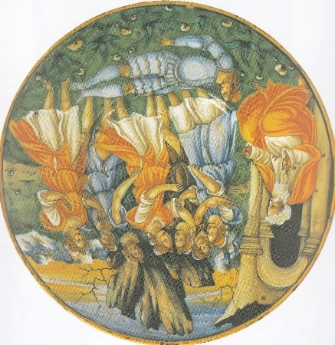
 | Aeneas meets Anchises in the Elysian Fields  Urbino, by Francesco Xanto Avelli, 1535, lustred in Urbino or Gubbio  Inscribed: .1535. pie[n] di Letitia Anchise al figlio corre F.X.R.  Museo Correr, Venice.  Bibliog: Marcantoni Cherido 2022, no. 45; Brody 2024, pp. 143-5. | 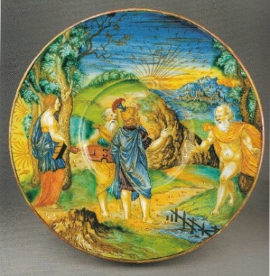
 | This Aeneas and Anchises in the Elysian Fields subject from Aeneid book 6, 679-702 is a composition due to Xanto and with a semi-verse inscription probably composed by him. A version of 1537 by Xanto, with the composition reversed and a different inscription, Nei ca[m]pi Elisi il pio Troiano, e’l padre. F.X.R. (Lessmann 1979, no. 146) is in Braunschweig. Brody 2024 notes examples of the Xanto composition by his associates Sforza di Marcantonio (c1538-40, Brody-Minimo collection) and Lu. Ur. (1535, Hermitage). One dated 1544, probably by Sforza, was in the Delsette collection (Frati 1844, no. 199). See also the 1576 version by Sforza, below.
 | Anchises showing Aeneas his descendants  Urbino, by Francesco Xanto Avelli, 1535  Inscribed: MDXXXV. Mostra suoi desce[n]denti Anchise al figlio… campi Elisi F.X.  Louvre, R 200 (damaged)  Bibliog: Giacomotti 1974, no. 853. | 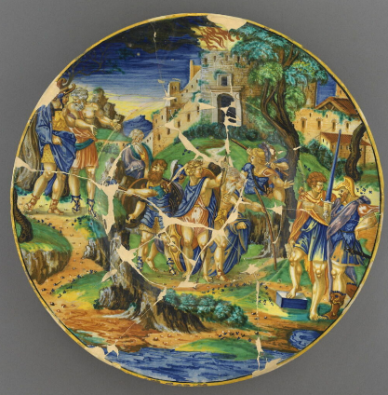
 | Anchises showing Aeneas his descendants  Urbino, by Francesco Xanto Avelli, 1535  Inscribed: MDXXXV. Mostra suoi disce[n]denti Anchise al figlio ne i campi Elisi F.X.  Formerly Kustgewerbemuseum, Leipzig; presumed destroyed in WWII.  Bibliog: Ballardini 1933-38, II, no. 193, figs 186, 348. | 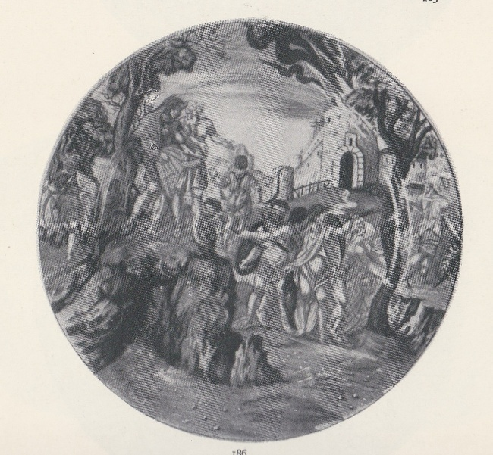
 | Aeneas, Anchises, Creusa, Ascanius, and the celestial flame  Urbino, by Francesco Xanto Avelli, 1535, from the Jacopo Pesaro service. Lustred in Gubbio or Urbino.  V&A, C 29-1943 | 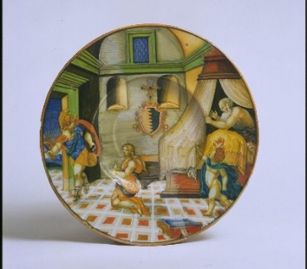
 | Cupid in the guise of Ascanius conducted to Dido by Achates.  Urbino, by Francesco Xanto Avelli, 1535. Lustred in Urbino or Gubbio.  Inscribed: 1535/ Mena Achate i[n] Cartago Aschanio à Dido. F.X.R.  V&A, C.479-1921.  Bibliog: Rackham 1940, no. 726; Sani 2007, no. 259 | 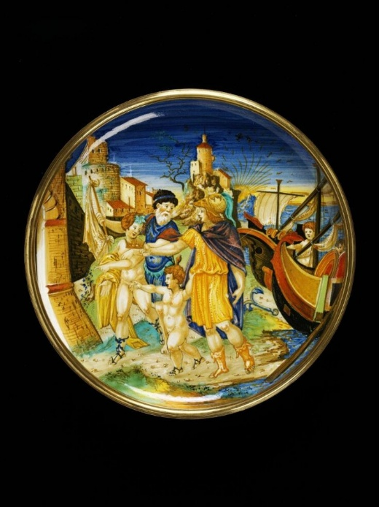
 | Cupid in the guise of Ascanius conducted to Dido by Achates.  Pesaro or Urbino, dated 1545, attributed on the V&A website to Sforza di Marcantonio, Pesaro (but by Rackham, implausibly, to the “Della Rovere painter”, Urbino).  Inscribed: mena Cato in Cartago Ascanio adido 1545  V&A 1745-1855  Bibliog: Rackham 1940, no. 874 | 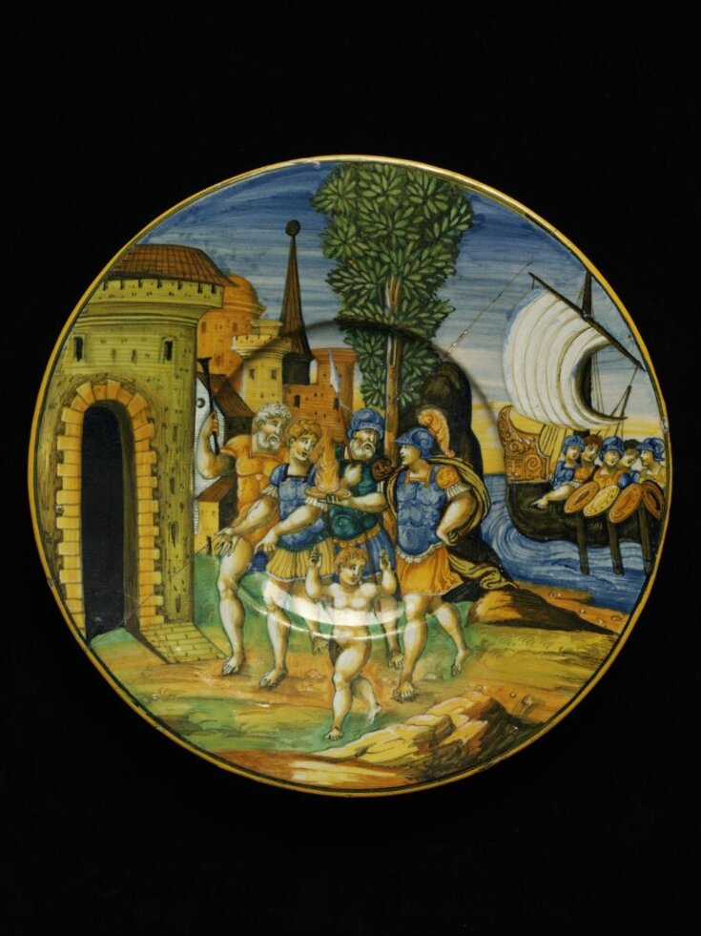
 | Cupid in the guise of Ascanius conducted to Dido.  Urbino, c1540-45, probably made in the workshop of Guido di Merlino.  Inscribed: Ascanio quando fu menato in catagine  MAK, Vienna, inv. KE 2519  Bibliog: Hollein, Franz, and Wilson 2022, no. 151 | 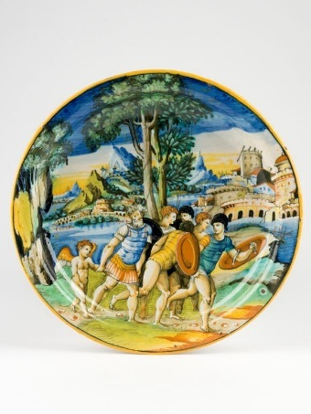
 | Dido bewailing the departure of Aeneas  Urbino, c1530-45, by an associate of Francesco Xanto Avelli (but also reminiscent of Francesco Durantino).  Inscribed: Da lalto scoglio le go[n]fiate vele Vede partir d[e]l suo signor crudele  Ex-Caruso sale, Sotheby’s, London, 20 March 1973, lot 39 (as perhaps by Xanto).  An alternative interpretation might be that this is Alcyone bewailing the departure of Ceyx, from Ovid’s Metamorphoses, Book 2 (compare Wilson 2017, no. 53), but the use of the word crudele makes the Dido interpretation more likely. | 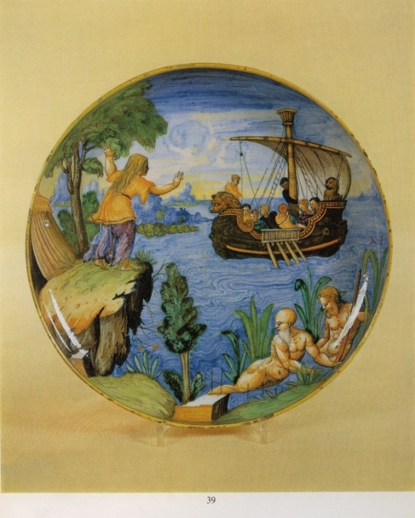
 | Aeneas’ arrival in Sicily  Urbino, c1545, probably workshop of Guido di Merlino/circle of Francesco Durantino, possibly by the “Painter of the Orpheus Basin”.  Inscribed: Comme enea delibero d[i] Andare p[er] mezzo il pellago ecomo arrivo initalia  Fondazione Cassa di Risparmio di Perugia  The inscription and composition are taken directly from the woodcut in the Virgilio volgare opening Book 5 of the Aeneid.  Bibliog: Wilson and Sani 2006-7, I, no. 45 | 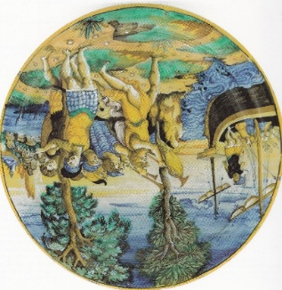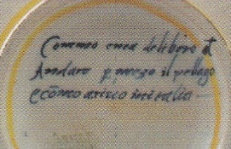
 | Woodcut opening Book 5 of the Aeneid in the Virgilio volgare (1528). | 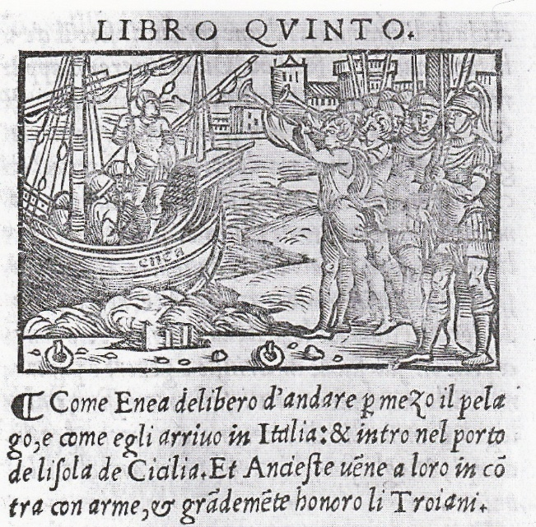
 | Aeneas’s arrival in Sicily  Verona, 1541 or (more probably) 1547, by Giulio da Urbino  Inscribed: 1547[?] come enea arrivo in italia  Kunstindustri Museet, Copenhagen.  Bibliog: Houkjaer 2005, no. 157  Based on the woodcut opening Book 5 in the Virgilio volgare and representing Aeneas’s welcome by Acestes in Sicily, not, as suggested by Houkjaer, his arrival at Cumae on the Italian mainland in Book 6. | 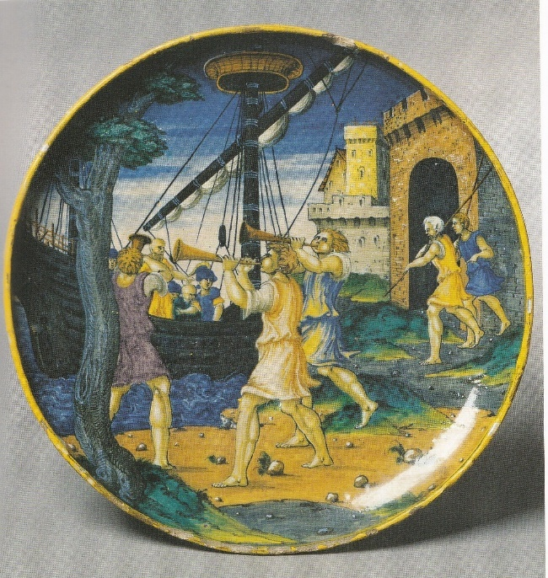
 | The Trojan women setting fire to the Trojan ships  Urbino, c1540-50, perhaps workshop of Guido di Merlino  Uninscribed  Braunschweig, Herzog Anton Ulrich Museum.  Bibliog: Lessmann 1979, no. 158  The subject as interpreted by Lessmann does not seem perfectly to correspond tto the text in Aeneid Book 5, 613ff. | 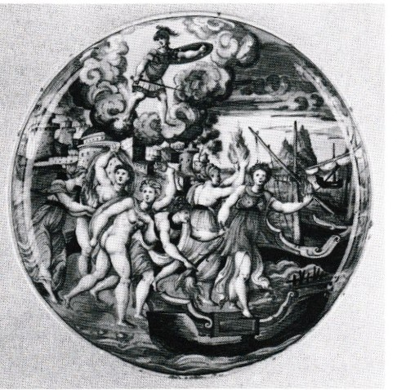
 | The Judgement of Paris  Urbino, 1531, by Francesco Xanto Avelli, arms of Eliseo Piani.  Inscribed: 1531. Per cui Troia superba fu combusta.favola.Fra[n]cesco Xanto, Avelli da Rovigo in Urbino Pi[n]se and round the rim: IUDITIUM PARIDIS. MANET ALTA MENTE REPOSITUM  Fitzwilliam Museum, Cambridge, C,86-1961  Bibliog: Poole 1995, p. 389; Mallet 2007 (Xanto), no. 33.  The Judgement of Paris is not really a Virgilian subject but this is included here since the Latin words are a (slightly inaccurate) quotation from Aeneid 1, 26. | 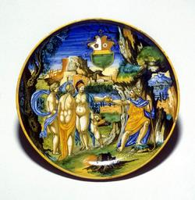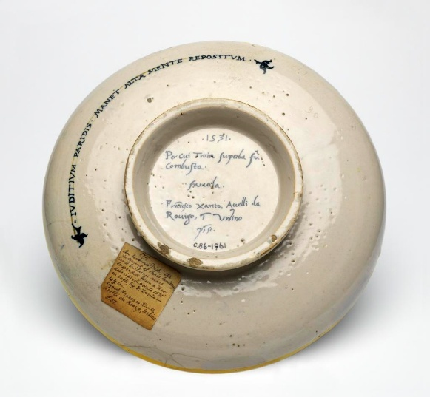
 | Aeneas at the Temple of Apollo  Urbino, 1543, by the “Coalmine painter” (perhaps Francesco di Silvano).  Inscribed: 1543 Enea. al te[m]pio. d[i]. palla. Urbino  Sam Fogg collection, London (ex Christie’s, 13 November 2018, lot 281).  Based on the woodcut opening Book 6 of the Aeneid in the Virgilio volgare. | 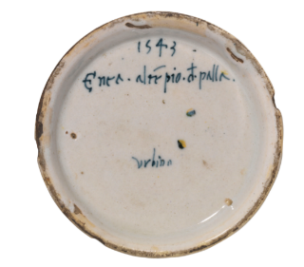  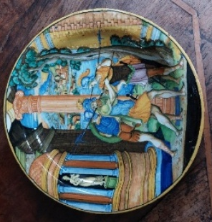
 | Woodcut opening Book 6 of the Aeneid in the Virgilio volgare, 1528. | 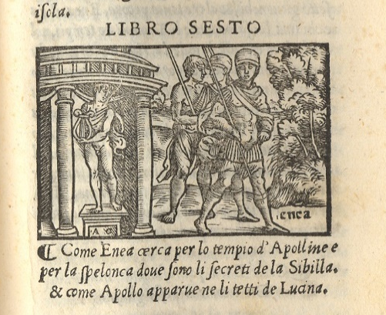
 | Aeneas ferried to the Underworld by Charon  Attributed by Ravanelli Guidotti to Tuscany, c1550-75  Inscribed: Passa londe Infernal il forte Enea  Collection of the Monte dei Paschi, Siena.  Bibliog: Ravanelli Guidotti 1992 (Chigi Saracini), no. 7.  A version of the same subject, uninscribed, is in the Musei Civici, Imola (Ravanelli Guidotti 1991 (Imola), no. 42. | 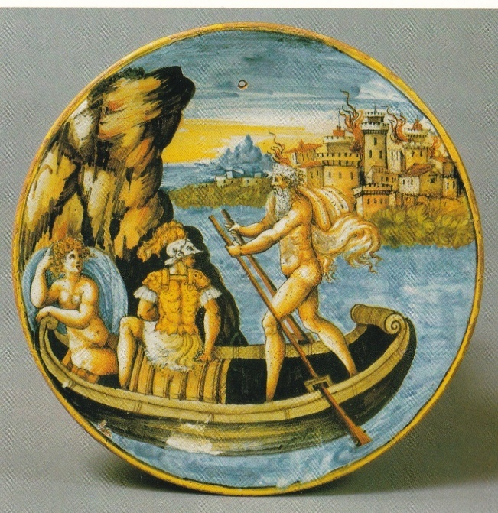
 | Laocoon  Urbino, by Francesco Xanto Avelli, Urbino, c1530  Inscribed: Co[n]templa exa[n]gue il fier Laocoonte. historia and the “y/phi flourish”.  Hermitage, Saint Petersburg  The main figure after the engraving by Marco Dente (below).  Bibliog: Ivanova 2019, no. 19. | 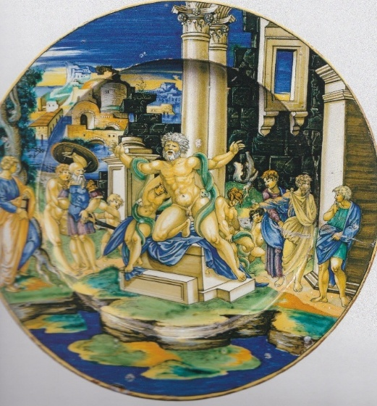
 | Laocoon  By Francesco Xanto Avelli, Urbino, 1532; lustred in Urbino or Gubbio  Inscribed: .1532./Da Serpi Laocoonte,e,i figli/uccisi, Nel.II.de la Eneida d[i] Vgilio.M. .fra[n]: xanto.A.da Rovigo, i[n]Urbino  After the same engraving.  MMA, New York, Lehman Collection, 1975.1.1129  Bibliog: Rasmusen 1989, no. 82 | 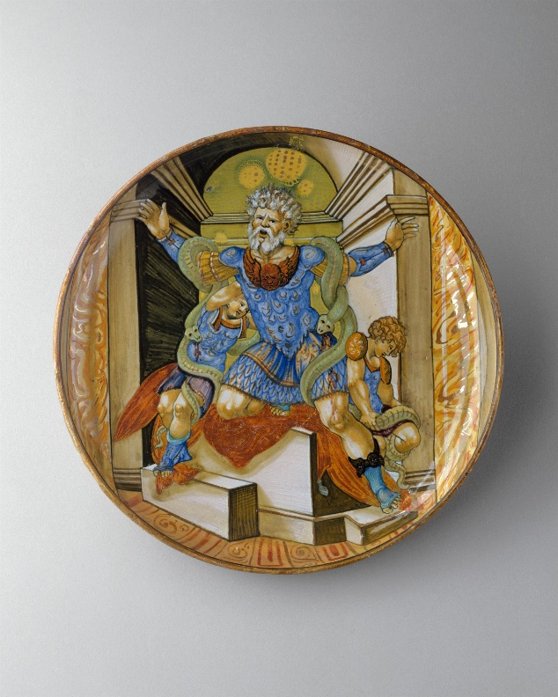
 | Laocoon  Urbino, probably by Francesco Xanto Avelli and an assistant, 1539. Lustred, probably in Urbino.  Inscribed: 1539/da duo gra[n] serpe/Laocaonte ucciso  National Gallery of Art, Washington, 1942.9.338.  Bibliog: Wilson 1993, pp. 215-7, with discussion of other versions by Xanto.  The main figure from the same Marco Dente da Ravenna engraving as the preceding two. This engraving underlies all the versions by Xanto and his circle, except the problematic fragmentary plate in Braunschweig, Lesssmann 1979, no. 140; Sani no. 66). | 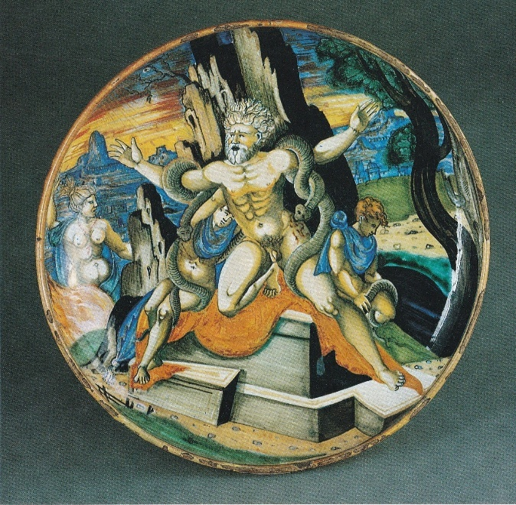
 | Other versions of this Laocoon type by Xanto: Sani 2007, nos 66 (c1530, fragmentary, Braunschweig, see note above), 67 (c1530, formerly Braunschweig, destroyed). Sani no. 409, in the Gardiner Museum, Toronto, G83.1.390, uninscribed, may be at least in part by Xanto. Strauch 2007, no. 4, illustrates one destroyed in Berlin in WWII from the set with arms with a star and fish, probably by an associate of Xanto (Sforza di Marcantonio?), c1538-9.
 | Laocoon  Engraving by Marco Dente da Ravenna  BM, P&D, H,7.40, dating it 1510-27. The engraving is partly based on a miniature in the fifth-century “Vatican Virgil”, which wss known in Raphael’s circle in Rome by c1515 and subsequently owned by Pietro Bembo; see D.H. Wright, The Vatican Vergil (1993), p. 111. | 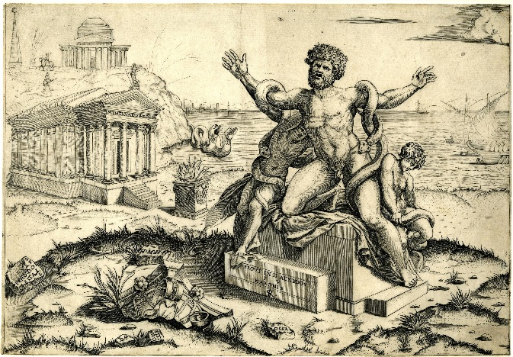
 | Laocoon  Probably Urbino, c1530-35  Musei del Castello Sforzesco, Milan.  Bibliog: Wilson in Ausenda 2000, no. 220.  The figures based on the engraving by Marco Dente (below). | 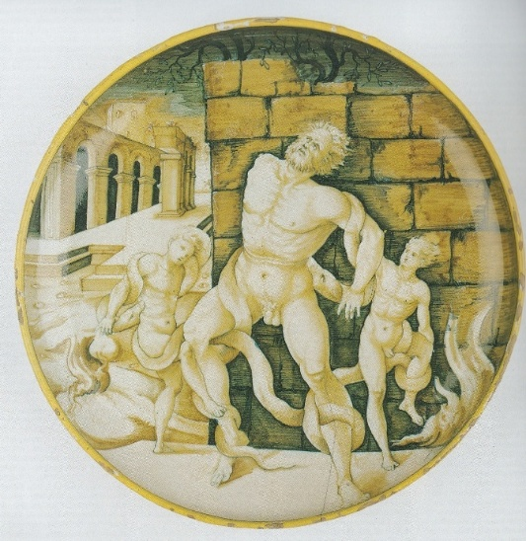
 | Laocoon  Engraving by Marco Dente da Ravenna  BM, P&D, H,7.58, dating it 1522-25. | 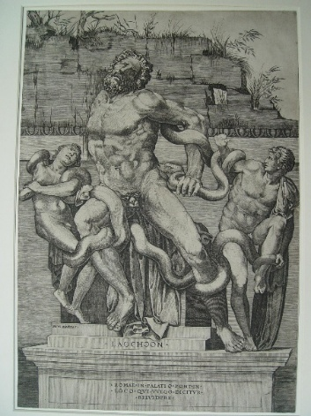
 | Laocoon  Urbino, probably Patanazzi workshop, c1580-1600  Museo de Arte de São Paulo (ex Fountaine and Imbert)  Bibliog: Strauch 2007, no. 11. He illustrates four other versions with similar standing figures of Laocoon, nos 12, 13, 14, 15, but does not identify a graphic source (though there must surely be one) | 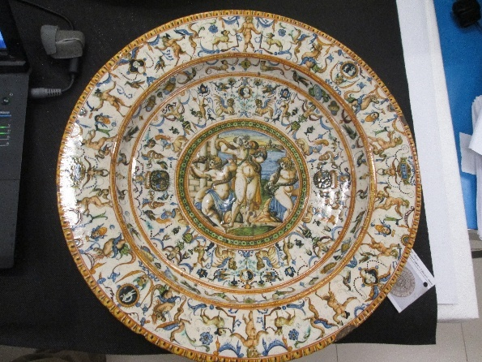
 | Representations of Laocoon are quite common on maiolica; Strauch 2007 lists 16 and illustrates most of them. None of those known to me except the MMA plate above make specific reference in the inscription to the Virgilian text, but focus on the sculpture. See also Bober and Rubinstein, no. 122.
 | Neptune from the Quos ego.  Faenza, workshop of Virgiliotto Calamelli, c1540-50.  Marked but no subject inscription.  Ashmolean, WA2005.205  Bibliog: Wilson 2017, no. 42 | 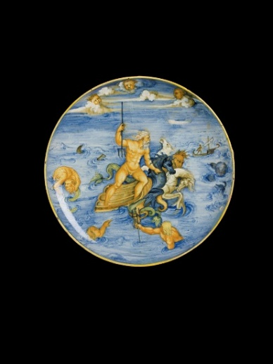
 | Quos ego. Engraving by Marcantonio Raimondi after Raphael, c1515.  A comparable representation of Neptune, monogrammed by Orazio Fontana and dated 1544, is in the Museum of Applied Arts, Budapest (Liverani 1957, tav. LXV). | 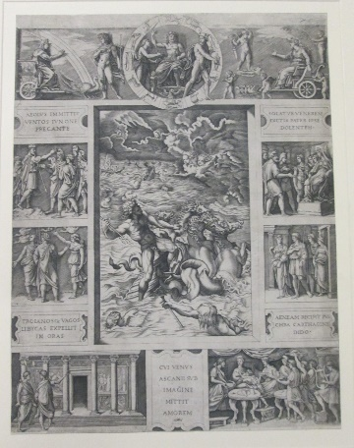
 | Scenes from the Quos ego  Perhaps Tuscany, c1525-50  Wallace Collection, C36  Bibliog: Norman 1976, pp. 88-90, listing other maiolica from the Quos ego. | 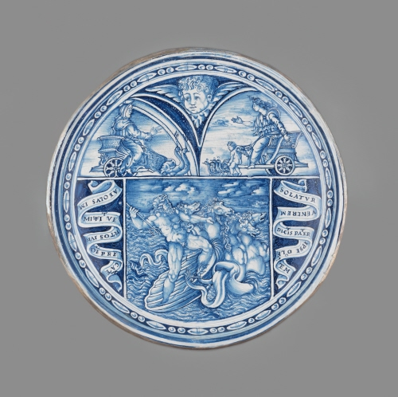
 | Aeolus raising the winds  Duchy of Urbino, c1530-40  Inscribed: Aeolus imitit vétos Iunone precante  Museo d’arte medioevale e moderna, Arezzo  Bibliog: Fuchs 1993, no. 156 (as circle of Nicola)  The inscription is from the Quos ego. The composition, with a gratuitous naked lady, owes nothing else to the engraving, but slightly resembles the plate below. | 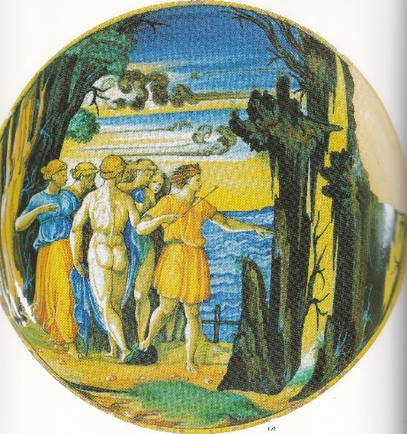
 | Aeolus raising the winds  Duchy of Urbino (Pesaro?), c1550-60  Musei Civici, Pesaro  Inscribed: Eulus e giunone  Bibliog: Giardini 1996, no. 60.  Unrelated to the Quos ego. | 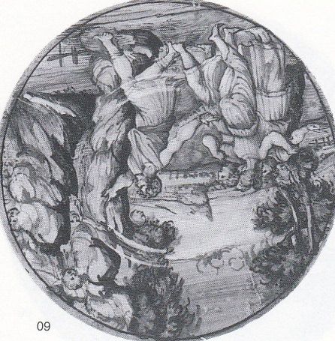
 | Aeneas, Anchises, Ascanius, and Creusa escaping from Troy  Perhaps Duchy of Urbino, c1535-45  Uninscribed.  Museo d’arte medioevale e moderna, Arezzo  Bibliog: Fuchs 1993, no. 58 (as Rimini)  Design unrelated to the Raphael composition or to other maiolica versions. | 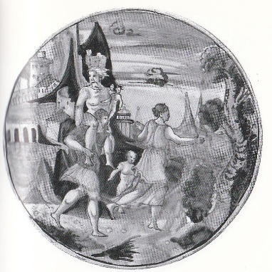
 | The capture of Sinon by the shepherds  Urbino, c1545.  Inscribed: ecco intento i pastor troianisieme conducano Al re Conalte grigda aninte un buon tre havea lonea lornandietre P.  Ashmolean, WA2022.706  Bibliog: Wilson et al 2025, no. 5. | 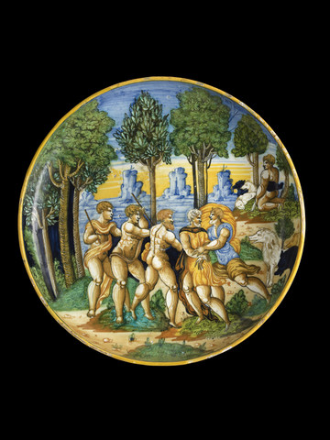
 | The Fall of Troy  Probably Urbino or Urbino district, or by an Urbino-trained painter working elsewhere, c1543-60.  Inscribed: Li ncendio di troia  Private collection  After an engraving by Giorgio Ghisi (below)  Bibliog: Wilson 2018, no. 145  A plate in the Philadelphia Museum of Art (Watson 2001, no. 4), made in Venice in the workshop of Francesco di Piero da Castel Durante in 1546 is inscribed Roina di troia, but depicts a cavalry battle, based indirectly on designs by Giulio Romano and Raphael, but far removed from Virgil’s narrative. The same is true of a plate marked Questa sie larovina de troia, with the monogram of Orazio Fontana and the date 1543, restituted by the MAK, Vienna, to the Rothschild family, sold at Christie’s, London, 8 July 1999, lot 142, and now in the Sam Fogg collection. Plates inscribed L’incendio di Troia based on engravings after Raphael’s Fire in the Borgo include one in the Bargello (Marini 2024, no. 285) and one from the Andrea da Volterra set in Detroit (Darr, Simons, and Wilson 2013, no. 18). | 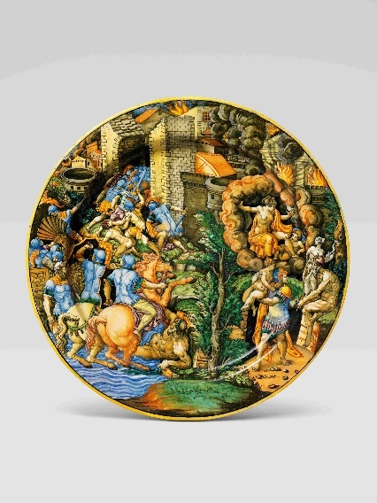
 | The Fall of Troy.  Engraving by Giorgio Ghisi after Giovanni Battista Scultori, c1543.  The figure supposed to be Aeneas appears to be carrying a female figure (Creusa? or a devotional sculpture?), rather than Anchises. | 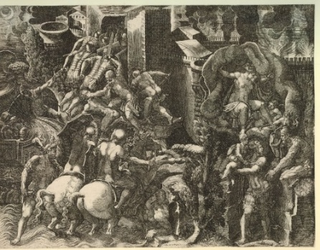
 | Metabus and Camilla  Urbino, 1543, perhaps made in the workshop of Guido di Merlino.  Inscribed: 1543. Scampo di Camilla in Urbino :P:  Erddig (National Trust)  Bibliog: Mallet 1978 [Erddig], pp. 42-3. | 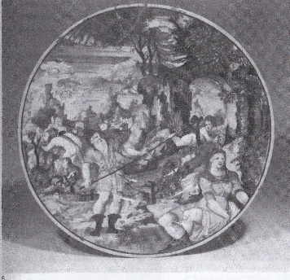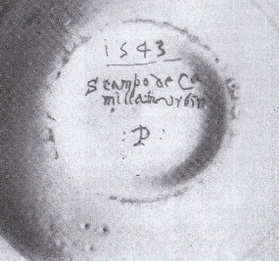
 | Metabus and Camilla  Probably Urbino, perhaps Fontana (Durantino) workshop, c1545-55.  Incribed: Il sca[m]po d[i] camila  Private collection (thanks to Carmen Ravanelli Guidotti) | 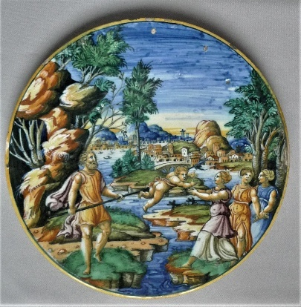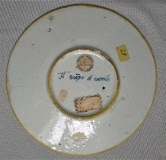
 | Sinon brought before Priam  Probably Duchy of Urbino, c1540-60  Uninscribed.  Musei Civici, Pesaro  Bibliog: Giardini 1996, no. 99. | 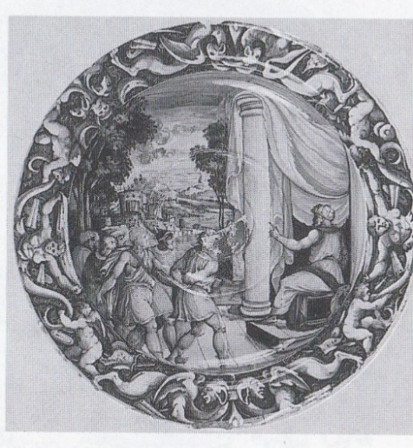
 | Aeneas and Achates at Carthage (Sunt lacrimae scene)  Urbino, by Francesco Durantino, 1545  Inscribed: ala citta d[i] dido pie[n] da miratio[n]e il buon Troiano 1545  (the verse-like line being the maiolica-painter’s invention?)  The figures and part of the architecture are from the corresponding vignette in the Quos ego.  Ashmolean Museum, WA2014.54.  Bibliog: Wilson 2017, no. 66. | 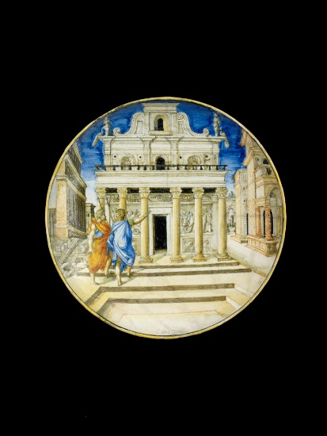
 | Candlestick, Vulcan at his forge with Venus and Cupid  Urbino, workshop of Guido Durantino, 1535  MMA, NY, Lehman Collection, 1975.1.1122  From the Montmorency set  Interpreted by Rasmussen as Vulcan forging arms for Aeneas at the request of Venus (Aeneid, Book 8, 378-453), but this and other versions of this common subject are not Virgilian but the more general subject of Vulcan forging arrows for Cupid at the request of Venus; see Hollein, Franz, and Wilson 2022, no. 84.  Bibliog: Rasmussen 1989, no. 91 | 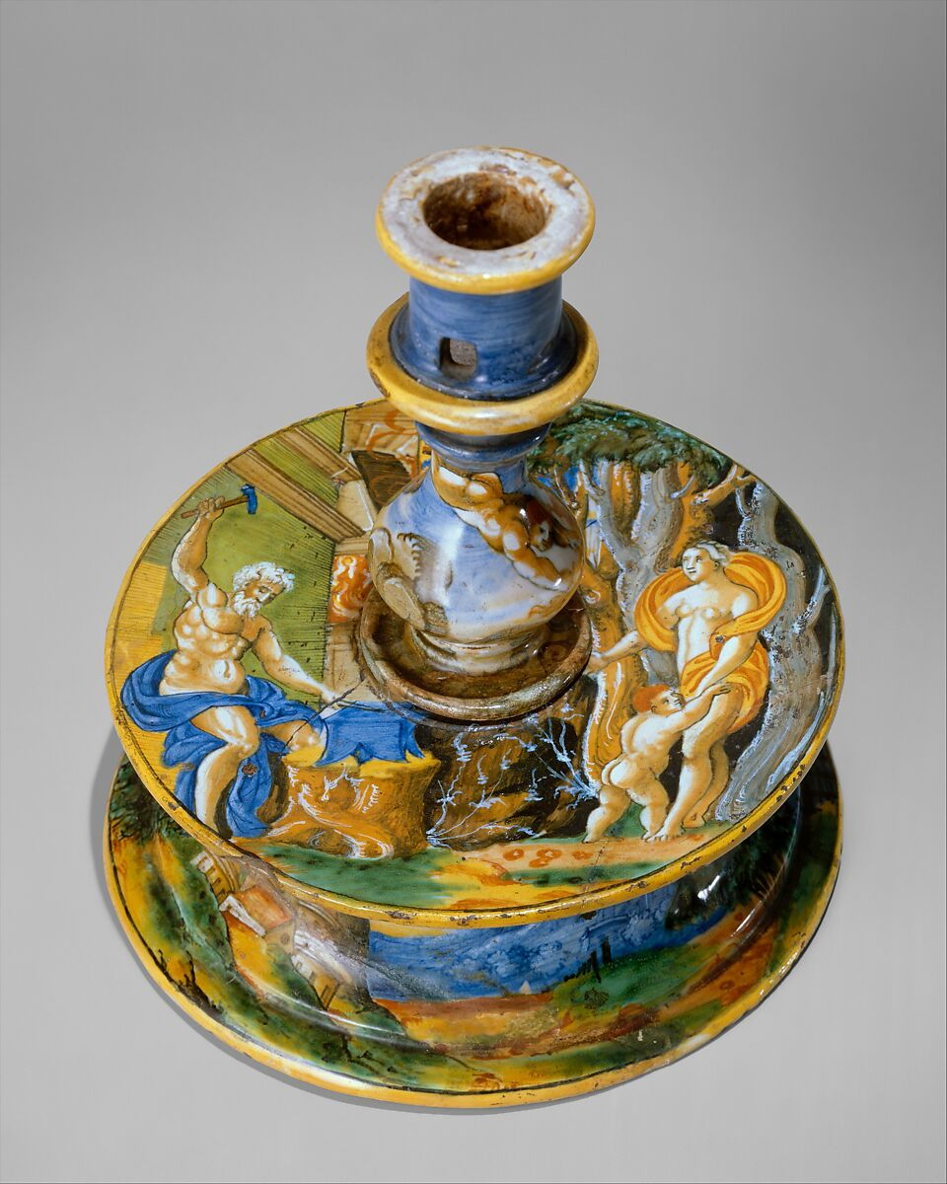
 | Aeneas, Anchises, and Ascanius escaping from Troy.  Venice, workshop of Domenego da Venezia and perhaps painted by him, c1560-90.  Inscribed: ilvehio.anchise ditroia.  Braunschweig, Herzog Anton Ulrich Museum.  After the Caraglio engraving or a version of it.  Bibliog: Lessmann 1979, no. 678  Another version of the subject, from the same workshop, is also in Braunschweig, Lessmann 1979, no. 716. | 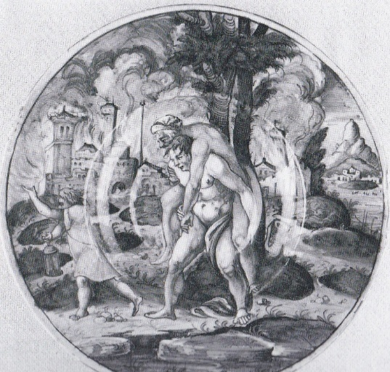
 | Aeneas, Anchises, and Ascanius escaping from Troy, with Creusa.  Perhaps Urbino or by an Urbino-trained painter working elsewhere, c1550-70  Inscribed: L’incendio di troija  Hetjens Museum, Dusseldorf  Loosely echoing the Caraglio engraving | 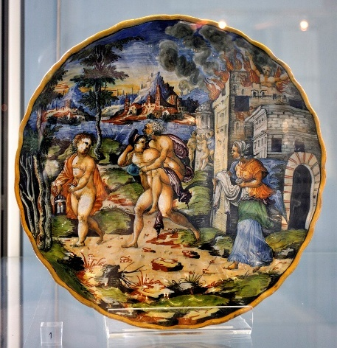
 | Aeneas’s ships burnt by Turnus transformed into tree-spirits  Attributed to the Zenobia Painter, Pesaro, c1545-50  Inscribed: Le nave de Enea Arse da Turno si conversero in Allbore  Private collection, ex-Justin Raccanello.  Illustration of the curious and unusual episode at the beginning of Book 9 of the Aeneid. | 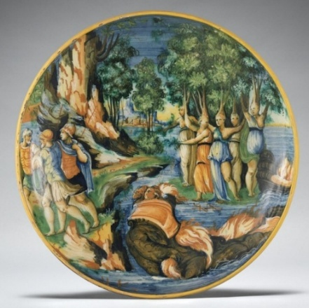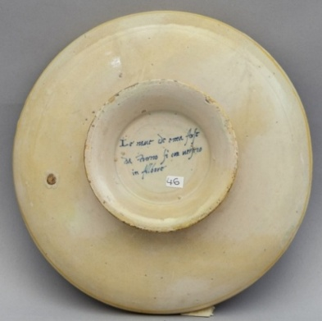
 | Aeneas meeting Anchises  Pesaro, by Sforza di Marcantonio, 1576.  Inscribed: Anchise & il figlio Enea.1576.S.  Private collection  The subject is presumably the meeting of Aeneas and Anchises in the Elysian Fields, though there is no visual reference to the Underworld. | 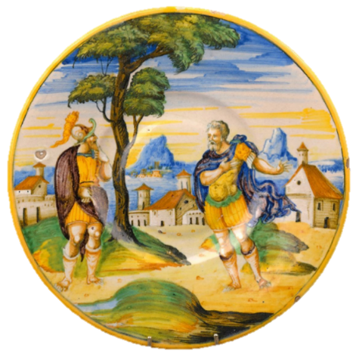
 | Aeneas and companions before Dido  Castel Durante, workshop of the Picchi brothers, perhaps painted by Andrea da Negroponte, c1550-60  Inscribed: henea ch[e] parlano co[n] la regina dido.  Braunschweig, Herzog Anton Ulrich Museum.  Bibliog: Lessmann 1979, no. 103 | 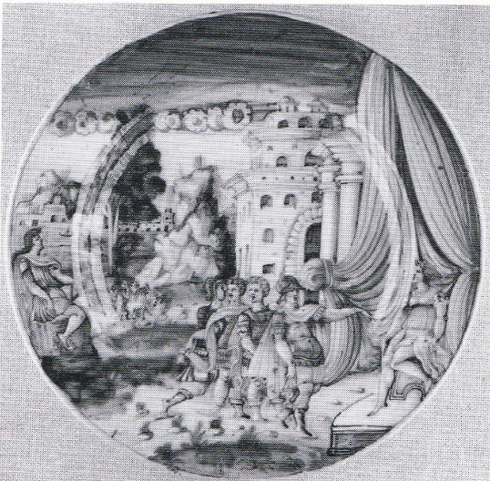
 | Sinon before Priam  Castel Durante, workshop of the Picchi brothers, perhaps painted by Andrea da Negroponte, c1550-60, from an armorial service.  Inscribed: quando Senone fo apresentato al re Troiano  Louvre, OA 1592  Bibliog: Giacomotti 1974, no. 1022. | 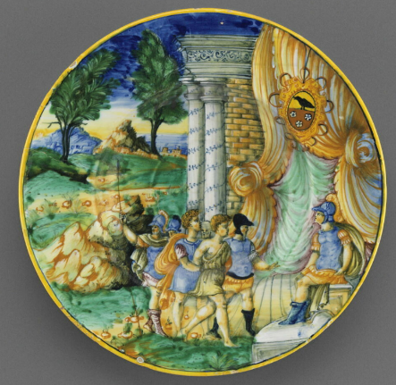
 | Sinon before Priam  Castel Durante, workshop of the Picchi brothers, perhaps painted by Andrea da Negroponte, c1550-60.  Inscribed: senone fu apresentato alo Re Troiano  Galleria Estense, Modena  Bibliog: Sassuolo 2000, p. 130. | 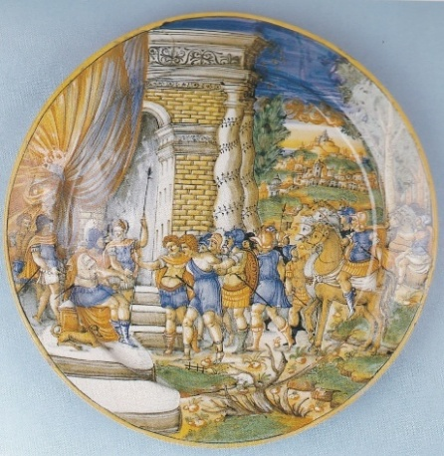
 | The Trojan horse  Castel Durante, workshop of the Picchi brothers, perhaps painted by Andrea da Negroponte, c1550-60.  Inscribed: Il cavallo di Troia  Museo d’arte medioevale e moderna, Arezzo  Bibliog: Fuchs 1993, no. 224.  A drawing attributed to Battista Franco may be for a scene of The Greeks entering the Trojan horse, but no extant maiolica taken from it is recorded by Clifford and Mallet 1976, fig. 67. | 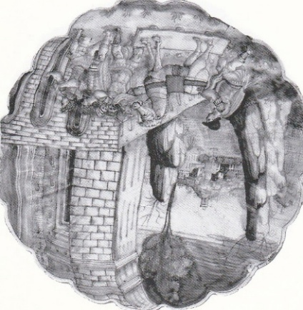
 | Aeneas and his family escaping from Troy.  Castel Durante, workshop of the Picchi brothers, perhaps painted by Andrea da Negroponte, c1550-60.  Inscribed: he[nea] quando fugia d[e] troia  Musei Vaticani  Bibliog: Pesante 2020, no. 28. | 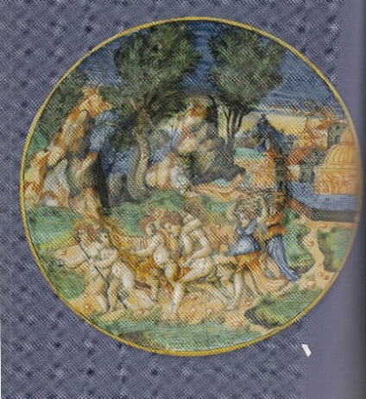
 | Aeneas’s dream of the River Tiber [?]  Origin uncertain, possibly Mantua or Bologna, dated 1555.  Uninscribed, but with imprese thought to relate to Vespasiano Gonzaga. In the background the city of Bologna.  Bibliog: Watson 2001, no. 55  The scene, somewhat in the manner of Battista Franco, is interpreted by Watson as Aeneas’ dream of the River Tiber prophesying future greatness (Aeneid, Book 8, 31-65). However, this leaves the woman entering a temple unexplained; and the sow which is a feature of Virgil’s narrative is missing, so the identification is speculative. | 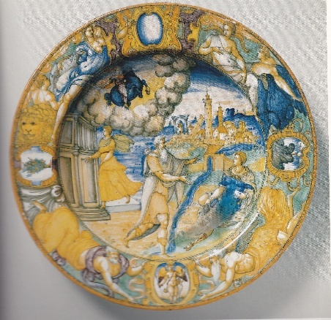

Creusa  Urbino or Castel Durante, c1520-25.  Uninscribed on the back  Waddesdon Manor  Part of a wonderful-quality series of helmeted heroes and heroines, from ancient and modern history and literature (for which see Thornton and Wilson 2009, no. 204). “Creusa” is the only distinctively Virgilian name that has been noted (there are maiolica belle called “Camilla”, but unless helmeted there is unlikely to be a Virgilian reference). | 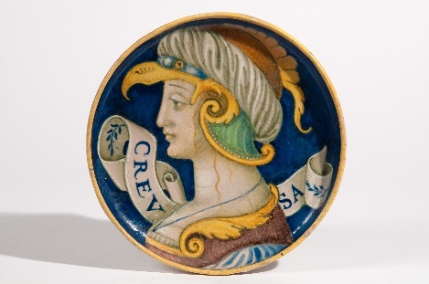
Albarelli, VARGI and ANCISA  Faenza, c1550  MMA, New York, Lehman Collection, 1975.1.993 and 994  Bibliog: Rasmussen 1989, nos 30, 31  Presumably for “Virgilio” and “Anchise” | 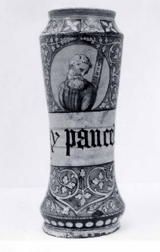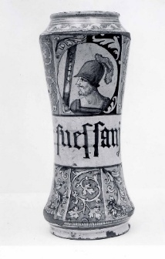
Plate with VRGILIO MA[N]TOANA  Urbino district, c1525-30  Wallace Collection, C43  Bibliog: Norman 1976, pp. 102-3, with an improbable attribution to Nicola da Urbino in Fabriano. | 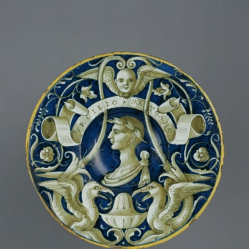

Two Dante subjects in which Virgil appears  Dante and Virgil in Hell with Homer and the poets (Inferno IV, 88090)  Urbino, by an associate of Nicola da Urbino, c1532, from the Leonardi service.  Musei Civici, Pesaro.  Bibliog: Giardini 1996, no. 111  Two plaques deceptively copying this subject can be attributed to Ferruccio Mengaroni: Ravanelli Guidotti 2010E, tav. 34; Riccetti 2017, p. 334, no. 502. | 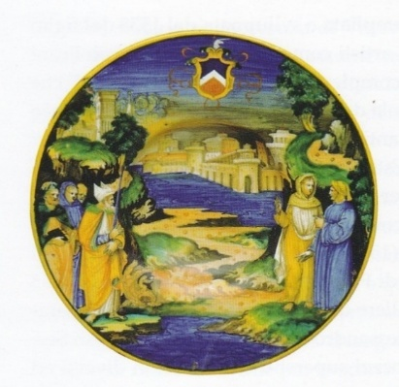
Dante and Virgil encounter, among the traitors, Count Ugolino di Guelfo della Gherardesca and Archbishop Ruggieri degli Ubaldini (Inferno, cantos 32, 33).  Urbino, by the painter of the Apollo Basin, 1531, probably lustred in Gubbio.  Private collection, ex Grazia Biscontini Ugolini; Wannenes, Milan, 1 July 2020, lot 702. | 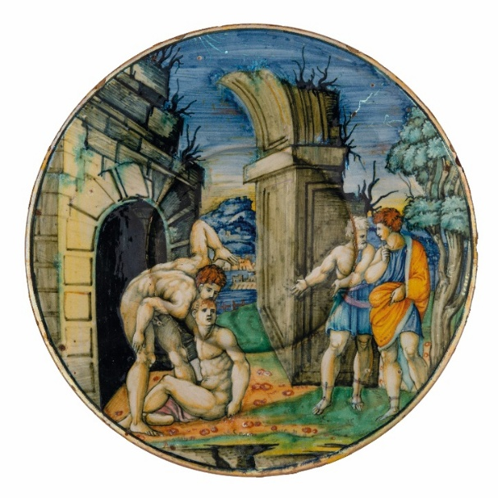

Trojan War subjects after Battista Franco

In 1547-48 Guidubaldo II, Duke of Urbino, as related by Vasari, commissioned Battista Franco to provide drawings for an unprecedentedly ambitious maiolica service depicting scenes from the Trojan Wars. Over twenty subjects are recorded in drawings or maiolica, ranging from the Judgement of Paris to the Death of Priam at the hands of Pyrrhus, the madness of Hecuba, and Aeneas meeting the ghost of Creusa. The service was magisterially studied by Cifford and Mallet 1976. Services were made, almost certainly in the Urbino workshops of the Fontana family, and given to the Emperor Charles V and to Cardinal Alessandro Farnese. The first service made from the drawings was followed by other versions for several decades.

Clifford and Mallet (1976, p. 395) conclude that “it is apparent that the subjects are not taken from one text, nor copied or adapted from an existing series of engravings or woodcuts…. The use of varied literary sources including, for example, an illustration of obscure incidents described by ancient commentators on Virgil, suggest that a humanist working for Guidubaldo was responsible for drawing up a programme for Franco to illustrate”. One possible candidate is Annibale Caro; Pietro Aretino has also been suggested.

Many of the subjects of Franco’s service are not from the Aeneid. Those that are include Pyrrhus killing Priam, Aeneas restrained by Venus from killing Helen, Ascanius and the celestial flame, Aeneas and Anchises escaping from Troy, with Ascanius and Creusa, and Aeneas encountering the ghost of Creusa. All these episodes are described in Aeneid, Book 2.

Pyrrhus killing Priam  Urbino, perhaps Fontana workshops, after 1547  Inscribed: PRIAMO OCCISO A L ALTAR DAL CRUDEL PYRRHO  Ex-Zschille. present location unknown.  Bibliog: Galeazzi and Valentini 1975, p. 103; Clifford and Mallet 1976, no. 15.  A later version of the design is on a plate in the Ashmolean, Wilson 2017, no. 130. | 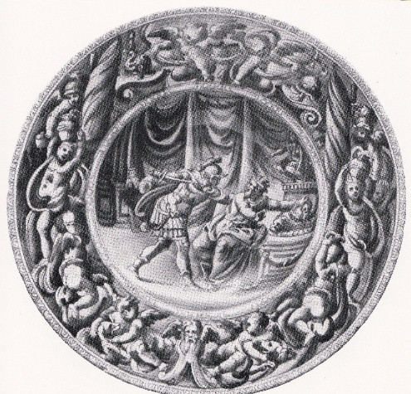
Pyrrhus killing Priam  Urbino, probably after 1547  Inscribed: Come pirro figliolo de Achille uccise il Re Priamo-  Wallace Collection, C139  Bibliog: Norman 1976, pp. 275-6; Clifford and Mallet 1976, no. 15.  The design differs from the preceding, but the figures of Pyrrhus and Priam are related and the painter is likely, directly or indirectly, to have known Franco’s drawing. | 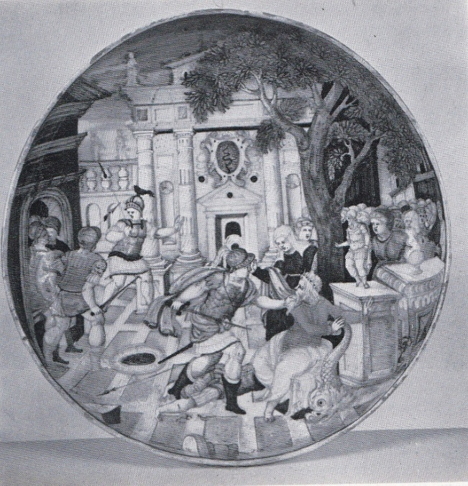
Aeneas restrained by Venus from killing Helen  Probably Urbino, late 16th century.  Uninscribed  Musei Civici, Pesaro  Bibliog: Clifford and Mallet no. 16; Giardini 1996, no. 186.  Looks much later than the “first service”, but likely to go back to a Franco design, though Clifford and Mallet conclude it is so mediocre that it “may not be taken from a Franco design at all”. | 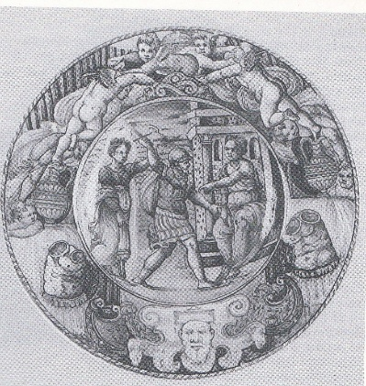
Aeneas, Anchises, Ascanius, and the celestial flame  Urbino, perhaps Fontana workshops, after 1547  Inscribed: ASCANIO CH’HA LA FIAMMA AL CAPO AVOLTA  Musei Civici, Pesaro.  Franco’s drawing is in the Kunstbibliothek, Berlin.  Bibliog: Clifford and Mallet 1976, no. 17; Giardini 1996, no. 189 | 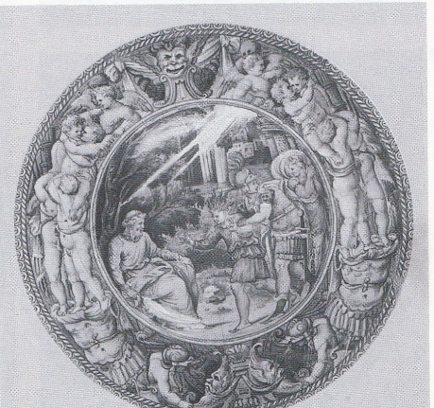
Aeneas, Anchises, and Ascanius, with Creusa, esaping from Troy  Presumably Urbino, perhaps Fontana workshops, after 1547.  Inscribed: ENEA SU’GLI UMER PORTA IL PADRE ANCHISE  Location unknown, formerly Spitzer.  Bibliog: Molinier 1892, no. 62; Clifford and Mallet 1976, no. 19.  Presumably from the drawing by Franco now in Oporto, Clifford and Mallet with no. 19, fig. 77. | No photo known to me. Seemingly not illustrated by Molinier or in the photo album made at the time of the Spitzer sale.
Aeneas, Anchises, and Ascanius escaping from Troy, while Creusa is carried off by the Corybantes  Urbino, perhaps Fontana workshops, after 1547.  Inscribed: I CORIBANTI A ENEA RAPIR CREUSA  Musei Civici, Pesaro.  Bibliog: Clifford and Mallet 1976, no. 19a; Giardini 1996, no. XXII; E. Panizon, “Ascanio e Creusa nelle rappresentazioni pittoriche delle fuga di Enea: il caso dell’affresco di Ludovico Carracci in Palazzo Ratta a Bologna”, Pan, Rivista di filologia latina, n.s. 8 (2019), p. 139 (thanks to Matthew Robinson for this reference).  The story of Creusa being abducted by the Corybantes, priests of Cybele, and killed is not in Virgil, though the commentator Servius has a brief ref to the Corybantes. The episode is mentioned in Renaissance Latin commentaries on Virgil; but I have not found it in any Italian-language edition. Another version of the subject seemingly designed by Franco (ex-Spitzer, above), has no reference to the Corybantes. | 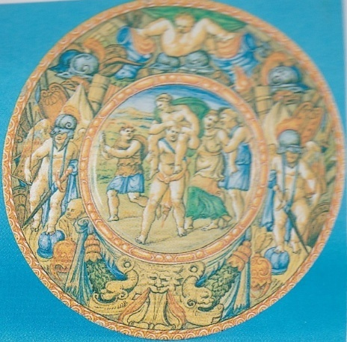
Annotation to the account of Creusa’a disappearance and re-appearing to Aeneas in Aeneid book 2, from P. Virgilii Maronis poetarum facile principis Bucolica et Georgica cum disertissimis Servii Mauri honorati…. Venice, 1500, Aeneid, book 2, fol LXXXIIIr. I thank Philip Hardie and Matthew Robinson comments on this; the annotations seem to derive from more than one ancient commentary; “Donatus”, cited, is the commentator Tiberius Claudius Donatus. Further discussed by Panizon 2019. | 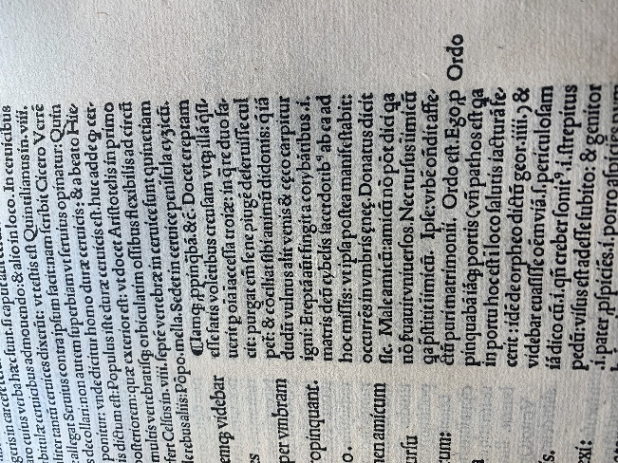
Aeneas encountering the ghost of Creusa  Probably Urbino, perhaps Fontana workshops, after 1547.  Location unknown, formerly Spitzer.  Inscribed: L’OMBRA PARLA AD ENEA DE LA SUA DONNA  Bibliog: Molinier 1892, no. 136; Clifford and Mallet 1976, no. 20. | No photo known to me. Seemingly not illustrated by Molinier or in the photo album made at the time of the Spitzer sale.

